**BakeJourney**

PROJECT REPORT SUBMITTED IN PARTIAL FULFILMENT OF THE

REQUIREMENTS FOR THE AWARD OF

**BACHELOR OF COMPUTER APPLICATIONS**

To

**MARIAN COLLEGE KUTTIKKANAM AUTONOMOUS**

Affiliated to

**MAHATMA GANDHI UNIVERSITY, KOTTAYAM**

By

**ACSAH ROJAN**

(Reg.No: 23UBC202)

**ANU ELIZEBATH KURUVILLA**

(Reg.No: 23UBC218)

Guided By

**Mrs. DONAMOL JOSEPH**



**DEPARTMENT OF COMPUTER APPLICATIONS**

**MARIAN COLLEGE KUTTIKKANAM AUTONOMOUS**

**PEERMADE – 685531**

**OCTOBER, 2025**

**DECLARATION**

We, **ACSAH ROJAN [Reg.no 23UBC202]**, **ANU ELIZEBATH KURUVILLA [Reg.no 23UBC218]** certify that the Mini project report entitled **“BakeJourney”** is an authentic work carried out by us at Marian College Kuttikkanam Autonomous. The matter embodied in this project work has not been submitted elsewhere for the award of any degree or diploma to the best of our knowledge and belief.

Signature of the Students:

**ACSAH ROJAN**

**ANU ELIZEBATH KURUVILLA**

Date:

**BONAFIDE CERTIFICATE**

This is to certify that this project work entitled “BakeJourney” is a Bonafide record of work done by **Ms. ANU ELIZEBATH KURUVILLA [Reg.no 23UBC218]**, **Ms. ACSAH ROJAN [Reg.no 23UBC202]** at Marian College Kuttikkanam Autonomous in partial fulfilment for the award of the **Degree of Bachelor of Computer Applications of Mahatma Gandhi University, Kottayam**.

This work has not been submitted elsewhere for the award of any degree to the best of our knowledge.

Head of the Department

**Dr. Rajimol A**

Dept. of Computer Applications

Marian College Kuttikanam

Peermade - 685531

Internal Guide

**Ms. Donamol Joseph**

Dept. of Computer Applications

Marian College Kuttikanam

Peermade - 685531

Submitted for the Viva-Voce Examination held on

**DEPARTMENT SEAL**

**EXTERNAL EXAMINER**

**ACKNOWLEDGEMENT**

“Gratitude is not only the greatest of virtues but the parent of all others.”

– Marcus Tullius Cicero

The journey of creating this project was one we could not have undertaken alone. It was shaped and supported by the guidance, encouragement, and cooperation of many individuals and institutions. Their generous contributions made this endeavor possible, and we are deeply thankful.

We extend our heartfelt appreciation to our Manager, **V. Rev. Fr. Boby Alex Mannamplackal**, and **Dr. Ajimon George**, Principal of Marian College Kuttikkanam Autonomous, for their unwavering commitment to nurturing us within this esteemed institution.

Our sincere thanks go to **Dr. Rajimol A**, Head of the Department of Computer Applications, whose constant encouragement and insightful advice were instrumental in bringing this project to fruition.

We are especially grateful to our internal project guide, **Mrs. Donamol Joseph**, for her thoughtful mentorship and steady guidance throughout the course of this work.

We also wish to acknowledge the faculty members of the Department of Computer Applications for their timely support and valuable input at every stage.

Last but not least, we thank our friends and families for their moral support and encouragement, which gave us the strength to see this project through to completion.

With gratitude,

Acsah Rojan & Anu Elizebath Kuruvilla

**ABSTRACT**

**ABSTRACT**

The project named “BakeJourney” is an all-in-one web-based platform to bridge the gap between talented home bakers and dessert lovers. With the rise of small-scale bakers and growing demand for personalized, homemade treats, BakeJourney offers a dedicated space where home bakers can showcase their products, and customers can explore and order a wide variety of baked goods.

The platform uses HTML, CSS, and JavaScript for the front end, providing a clean, intuitive user interface. The back end, developed with PHP and MySQL, ensures robust data management and seamless functionality.

It will feature two user roles: Bakers and Customers. Bakers can create profiles, upload product listings, manage orders, and receive custom requests, submit personalized recipes, and engage with customers. Customers can browse baked goods, view baker profiles, place orders, request personalized cakes or treats, submit reviews, track orders, and make online transactions.

Additionally, the platform supports secure payment processing and smart searching and filtering functionalities.

The website aims to empower home bakers by giving them a digital storefront and enhance customer experience by offering easy access to fresh, homemade delights. This project not only intends to showcase web development skills but also promote small businesses and support local entrepreneurship.

|  |  |
| --- | --- |
| **TABLE OF CONTENTS** | |
| **TITLE** | **PAGE** |
| 1. **INTRODUCTION** | **9** |
| * 1. **ABOUT THE PROJECT**   2. **EXISTING SYSTEM**   3. **PROPOSED SYSTEM** | **10**  **11**  **11** |
| 1. **SYSTEM ANALYSIS** | **12** |
| * 1. **PROBLEM DEFINITION**   2. **FEASIBILITY ANALYSIS**   3. **RECOMMENDED IMPLEMENTATIONS** | **13**  **13**  **14** |
| 1. **SOFTWARE REQUIREMENT SPECIFICATION** | **16** |
| * 1. **PURPOSE**   2. **SCOPE**   3. **TECHNICAL OVERVIEW**   4. **FUNCTIONAL REQUIREMENTS**   5. **NON-FUNCTIONAL REQUIREMENTS**   6. **STATED REQUIREMENTS**   7. **EXTERNAL INTERFACE REQUIREMENTS** | **17**  **17**  **18**  **18**  **19**  **20**  **24** |
| 1. **SYSTEM DESIGN** | **26** |
| * 1. **DESIGN METHODOLOGY**   2. **SYSTEM ARCHITECTURE AND PROCESS FLOW**   3. **MODULE DETAILS**   4. **PERFORMANCE CONSIDERATIONS**   5. **SECURITY CONSIDERATIONS**   6. **TABLE DESIGN** | **28**  **31**  **37**  **38**  **38**  **39** |
| 1. **CODING** | **47** |
| * 1. **SELECTION OF SOFTWARE**   2. **CODING PHASE** | **48**  **49** |
| 1. **TESTING** | **50** |
| * 1. **TESTING**   2. **TESTING METHODS**   3. **IMPLEMENTATION** | **51**  **52**  **55** |
| 1. **MAINTENANCE AND ENHANCEMENT** | **56** |
| * 1. **MAINTENANCE**   2. **ENHANCEMENT** | **57**  **57** |
| 1. **CONCLUSION** | **59** |

# INTRODUCTION

1. **INTRODUCTION**

## ABOUT THE PROJECT

BakeJourney is a web-based platform developed to streamline business operations for small, home-based bakery entrepreneurs. It offers an integrated suite of features for managing products, handling customer orders, and engaging with customers—all through an intuitive interface. The project aims to bridge the gap between traditional home baking and modern digital tools, empowering bakers to grow and thrive.

* + 1. **THE PURPOSE AND SCOPE**

The purpose of *BakeJourney* is to empower small home-based bakery businesses by offering a streamlined digital platform for managing day-to-day operations. The website is designed to simplify order tracking, product management, customer interaction, and menu presentation, allowing bakers to focus more on their craft than on logistics. The scope of this project includes:

* Developing a web-based platform specifically for home-based bakery businesses.
* Enabling bakers to manage orders, update product listings, and interact with customers from a centralized dashboard.
* Providing features for customer engagement such as reviews, personalized menus, order-tracking and direct messaging.
* Allowing customers to browse and discover home bakers, place orders, and request customizations.
* Ensuring responsive design for seamless access on desktops and mobile devices.
* Supporting secure user authentication and data handling to protect both bakers and customers.
* Offering scalability to accommodate more users and features as the business grows.

## EXISTING SYSTEM

In the current scenario, most bakery management tools that exist today are geared toward commercial bakeries or general food service operations. These systems often lack the simplicity, affordability, and customer-facing features needed by small, home-based bakery businesses. As a result, there is a clear gap in the market for a platform like BakeJourney, which is purpose-built to support the unique needs of home bakers and their customers.

## PROPOSED SYSTEM

The main objective of the proposed BakeJourney website is to be a web platform tailored specifically for small-scale home bakers who may not have advanced technical skills. The system offers a clean, user-friendly interface that simplifies essential bakery operations like managing orders, updating menus, order tracking, and engaging with customers—without requiring any prior digital expertise.

The platform enables bakers to create and maintain their bakery profiles, display product listings with images and pricing, and receive customer orders seamlessly. Features such as profile setup tracking, minimalistic design, and mobile responsiveness ensure that even first-time digital users can navigate and manage their business effectively.

By empowering home bakers with intuitive tools, BakeJourney bridges the digital divide and supports their journey toward growth, professionalism, and local visibility.

# SYSTEM ANALYSIS

1. **SYSTEM ANALYSIS**

## PROBLEM DEFINITION

In today’s world, many home bakers still rely on traditional methods to manage their business. Customer orders are often taken through phone calls or messages, which can lead to confusion, missed details, or delays. Similarly, customers who want to explore different bakers and their products often find it difficult because there is no single platform that brings them all together. Record-keeping, order tracking, and communication are still handled manually in most cases, making the process inefficient. To overcome these challenges and provide a smoother experience for both bakers and customers, the BakeJourney platform is proposed.

* + 1. **ADVANTAGES OF PROPOSED SYSTEM**
* **Better Order Management:** The system validates user inputs and manages data properly, reducing duplication and confusion in orders.
* **Quick Access to Bakers and Products:** Customers can easily browse bakers, view products, and place orders faster than traditional methods.
* **Saves Time for Both Bakers and Customers:** Automated order placement, tracking, and updates reduce the effort and delays of manual communication.
* **Paperless Operations:** Everything from registration to order management is handled online, minimizing the need for physical records.
* **Accurate and Reliable Information:** The system provides up-to-date details about products, prices, availability, and order status, improving trust and decision-making.

## FEASIBILITY ANALYSIS

Feasibility study is a test of a system proposal according to its workability, ability to meet user needs and effective use of resources. The objective of feasibility is not to solve the problem but to acquire a sense of its scope. The main aim of the feasibility study is to test the technical, social and economic feasibility of the system. The feasibility study can be classified into the following categories:

* Operational Feasibility
* Technical Feasibility
* Economic Feasibility
  + 1. **OPERATIONAL FEASIBILITY**

The proposed system offers user friendliness combined with greater processing speed. Therefore, the work done can be reduced. Since the processing speed is very high compared with manual system a lot of time can be saved. The workload is reduced and this system requires only a small amount of work from Admin who manages the whole system. Hence, this project is operationally feasible.

* + 1. **TECHNICAL FEASIBILITY**

Technical feasibility checks if the required hardware and software can support the system. BakeJourney works smoothly on laptops, desktops, or smartphones with internet access. It is built using PHP, MySQL, HTML, CSS, and JavaScript, which are widely supported and need only minimal setup. Hence, the system is technically feasible.

* + 1. **ECONOMIC FEASIBILITY**

Economic feasibility ensures that the system is cost-effective. The existing manual process is time-consuming, error-prone, and inefficient. The proposed system processes information efficiently, saves time, and reduces errors through validation checks. Since it only requires basic hardware (already available) and free/open-source software, the cost is minimal. The benefits gained from improved accuracy and efficiency make the system economically feasible.

## RECOMMENDED IMPLEMENTATIONS

Two principal sources of data are:

* Written documents
* Data from the persons, who are involved in the operation of the system under study.

The different fact-finding techniques are:

* Questionnaires
* Personal Interviews
* Observations

**Questionnaires**

Questionnaires are best methods to probe data out of the customers. In this case, questionnaires were not used for data collection as the administration was small in number and they could be asked questions in a more effective interview.

**Personal Interviews**

Personal interviews were the main method of fact-finding for this project. Discussions were held with home bakers and customers to understand how orders, record-keeping, and communication were managed in the existing system. They also shared suggestions on features they wanted, such as easier product browsing, order tracking, and profile management. Most of these suggestions were included in system to make the system more practical and user-friendly.

**Observations**

A lot can be learned by simply observing how home bakers and customers interact in real life. By watching how orders are taken, products are showcased, and records are maintained, it became clear that most tasks rely heavily on manual effort and scattered communication. This observation highlighted the need for an organized online platform and inspired the design of a strong database model to handle bakers, customers, products, and orders efficiently in our system.

# SOFTWARE

# REQUIREMENT

# SPECIFICATIONS

1. **SOFTWARE REQUIREMENT SPECIFICATIONS**

Requirements specification is the starting step for the development activities. It is currently one of the weak areas of software engineering. During requirement specification, the goal is to produce a document of the client’s requirements. This document forms the basis of development and software validation. The basic reason for the difficulty in software requirements specification comes from the fact that there are three interested parties — the client, the end users, and the software developer.

## PURPOSE

The origin of most software systems is in the need of a client, who either wants to automate an existing manual system or desires a new software system. The software system itself is created by the developer. Finally, the completed system will be used by the end users. Thus, there are three major parties interested in a new system: the client, the users, and the developer. A basic purpose of software requirements specification is to bridge the communication gap. SRS is the medium through which the client and user needs are accurately specified. Indeed, SRS forms the basis of software development. A good SRS should satisfy all the parties, something very hard to achieve, and involves trade-offs and persuasion.

Another important purpose of developing an SRS is helping the clients understand their own needs. Advantages are:

* An SRS establishes the basis for agreement between the client and the supplier on what the software product will do.
* An SRS provides a reference for validation of the final product.
* A high-quality SRS is a prerequisite to high-quality software.
* A high-quality SRS reduces the development cost.

## SCOPE

* + 1. **SYSTEM STATEMENT OF SCOPE**

The BakeJourney platform is developed to provide small, home-based bakery businesses with a simple yet powerful tool for managing their operations and reaching local customers. The system covers order management, menu display, and customer interaction, all through an intuitive web interface tailored for users with minimal technical experience.

## TECHNICAL OVERVIEW

* + 1. **USER CHARACTERISTICS**

The system can be accessed by two types of users: Bakers (Admins) and Customers (Users). Bakers have access only to the admin dashboard, while users have access to the site and all its services. The admin functionalities are invisible to users.

## FUNCTIONAL REQUIREMENTS

The functional requirements of this website are as follows:

1. **User Management:** 
   * User Registration Process:
     + Users provide essential details like name, email, and password.
   * User Authentication:
     + Users log in by entering their registered email and password.
     + The system verifies credentials against stored data to allow access.
     + Users can securely log out, ending their active sessions to prevent unauthorized access.
2. **Product Management:**
   * Customers can explore bakers, browse products, place orders, and track their purchases easily.
   * Bakers can showcase products, manage incoming orders, and update their profile details from one place.
3. **Cart Management:**
   * Users can add or remove products from their cart.
   * The cart automatically updates quantities and total prices.
   * Users can view a summary of their cart, including item details and total cost.
4. **Order Management:**
   * The system collects all billing information during checkout.
   * Essential order details, such as product information, quantity, and customer details, are stored.
5. **Custom Order Management:**
   * Users can directly contact Bakers to discuss requirements.
6. **Purchase History:**
   * Users can view their purchase history, including product details, quantities, prices, and order dates.
   * Users can track their past orders conveniently.
7. **Blog Post Management:**
   * Customers can discover, read, like and comment on blog posts.
   * Bakers can easily create blog posts to increase engagement.
8. **Admin Dashboard:**
   * Bakers can oversee custom order discussions.
   * Bakers can manage website content and payments, before publication.
   * Bakers can monitor and ensure efficient order fulfilment.

## NON – FUNCTIONAL REQUIREMENTS

The non-functional requirements of this website are as follows:

1. **Usability:**
   * Intuitive and user-friendly interface.
   * Comprehensive design features and clear navigation.
2. **Reliability:**
   * System performs reliably in 95% of use cases monthly.
   * Ensure consistent and accurate data processing.
3. **Availability:**
   * Accessible globally 24/7.
   * Backup and recovery mechanisms to restore service within an hour of a failure.
4. **Security:**
   * Hourly backups of the database.
   * Secure handling of user data to protect privacy and prevent unauthorized access.
5. **Performance:**
   * Quick response times and minimal latency.
   * Efficient handling of large volumes of data.
6. **Scalability:**
   * Capable of supporting a growing number of users and transactions.
   * Modular architecture to facilitate easy expansion.
7. **Maintainability:**
   * Codebase should be well-documented and modular for ease of updates and bug fixes.
   * Regular maintenance schedules to ensure system health and performance.

## STATED REQUIREMENTS

* + 1. **GENERAL REQUIREMENTS**

The system has 6 functional modules divided between bakers and customers.

1. **Login:**
   * Only registered customers and bakers can log in to the system to avail the services.
   * The registered customers and bakers use their ID and password to log in.
   * The user ID should always be a valid email ID.
   * The password can contain both uppercase and lowercase alphabetic characters, numbers, and special characters.
   * Bakers will be redirected to the admin panel when logging in with the predefined ID and password using the same login form.
   * Users will be directed to the home page of the site when the login is successful.
2. **Sign Up:**
   * New users need to register in order to use the platform’s services.
   * This includes several fields:
     + Full Name
     + Email Address
     + Phone number
     + Country
     + State
     + Password
     + Confirm Password
3. **Admin Panel:**

This contains different admin processes such as:

* + - Managing products
    - Managing website content
    - Managing payments
    - Managing orders
    - Managing blogs

1. **Purchase Products:**
   * User can buy products listed on the platform.
   * Users can like or comment on products.
2. **Custom Order Booking:**
   * Users can book custom product orders by directly chatting with their baker of choice.
   * Users can manage their bookings and view details.
3. **Track Orders:**
   * Users can view the order status of their purchases.
   * Bakers can update the order status of their products.
4. **Blog Posts:**
   * Users can browse and view blog posts.
   * Bakers can add blog posts.
     1. **INPUTS**

The BakeJourney platform will take various inputs to provide its services:

* **Customer Registration:**
  + Full Name
  + Email Address
  + Phone Number
  + City
  + Password
  + Confirm Password
* **Login:**
  + Email Address (User ID)
  + Password
* **Order Placement:**
  + Product delivery location (depends on availability of service)
  + Preferred delivery date
* **Feedback:**
  + Full name
  + Email
  + Subject
  + Message
* **Add Products:**
  + Product name
  + Category
  + Price
  + Description
  + Image Upload
  + Weight
* **Add Blog Post:**
  + Blog title
  + Category
  + Content
  + Reading time
  + Image Upload
    1. **PROCESSING**

The system will perform the following key processing tasks:

* **Data Validation:**
  + Validate email format and password complexity.
  + Ensure required fields are not empty.
* **Identity Proofing:**
  + Validates identity of registered Bakers to ensure security and legitimacy.
* **Content Management:**
  + Bakers update and manage website content.
* **E-commerce:**
  + Users add products to cart, place orders, and track order history.
  + Secure payment processing.
    1. **OUTPUTS**

The system produces the following outputs:

* **Product Details:**
  + Product name, description, and pricing.
  + Product specifications.
* **Order and Payment Confirmation:**
  + Order details.
  + Payment confirmation.

## EXTERNAL INTERFACE REQUIREMENTS

* + 1. **USER INTERFACES**

All user interfaces will be GUI interfaces, designed for ease of use and high functionality. The interfaces will have a bright, pleasing appearance and intuitive design.

* **Design and Appearance:**
  + The interface will use suitable design elements and warm colors to create a welcoming and attractive environment for users.
  + Consistent design themes will be maintained across all pages.
* **Usability Components:**
  + Textboxes, combo boxes, and buttons will be used to facilitate easy data entry.
  + Clear labels and instructions will be provided for all input fields.
  + Intuitive navigation elements will help users move seamlessly through the platform.
* **Responsive Design:**
  + The user interface will be responsive to ensure usability across various devices, including desktops, tablets, and smartphones.
    1. **HARDWARE INTERFACES**

The system needs a computer or any other smart devices with network availability to access the web application. No other external hardware is required.

**Hardware Specification**

* **Processor**: Intel Pentium or higher
* **RAM**: 256 MB or higher
* **Hard** **Disk** **Drive**: 100 MB required on disk
* **Keyboard**: Standard QWERTY keyboard

**Implementation Specification**

* **Operating System**: Microsoft Windows 11
  + 1. **SOFTWARE INTERFACES**

**Software Specification**

* **Operating System**: Windows 11
* **DBMS**: MySQL
* **Tool Used**: PHP

# SYSTEM DESIGN

1. **SYSTEM DESIGN**

The design phase aims to develop a solution for the problems identified during the analysis phase. This phase marks the transition from understanding the problem to creating a solution. System design details the required features and operations, including screen layouts, business rules, process diagrams, pseudocode, and other relevant documentation.

During this phase, the overall structure and specifics of the software are defined. This includes determining the number of tiers needed for the architecture, designing inputs and outputs, and establishing database and data structure designs. Proper analysis and design are critical to the development cycle since errors in this phase can be costly to fix later. Therefore, careful attention is given during the design phase.

The logical framework of the product and its physical attributes are outlined during this stage. The operating environment is set up, and key resources are identified. Any element that requires user input or approval must be documented and reviewed by the user. The physical aspects of the system are specified, and a detailed design is prepared.

Subsystems identified during design are used to create a detailed system structure. Each subsystem is divided into one or more design units or modules, and detailed logic specifications are created for each module. The module logic is typically described in a high-level design language, which is independent of the final implementation language.

A good design should consider:

* **Promptness**: The design should be straightforward and clear, guiding users to their desired outcomes intuitively.
* **Memory Load**: Research shows that users can retain about six words in their short-term memory. The number of choices presented to users should ideally be four or fewer to prevent confusion and forgetfulness.
* **Service Reachability**: Users dislike going through many steps to access a service. More than five steps can cause impatience, so minimizing the number of steps helps reduce frustration.
* **Navigation**: Users should easily navigate back and forth between different steps, allowing them to access various parts of the dialog seamlessly.
* **Phonetic Similarity**: Avoid choices with similar pronunciations to reduce confusion and ensure users can clearly distinguish between options.
* **Error Handling**: Implementing graceful error handling helps decrease dependency on operators by managing mistakes effectively.
* **User Updates**: Keep users informed about the ongoing process to maintain their engagement and understanding.

For the general design, one or more potential designs are proposed and broadly sketched. These alternatives are then presented to the users, who choose the design that best suits their requirements while staying within project constraints.

The detailed design stage specifies the user interface, database, programs, hardware, and training and system documentation. Several structured techniques are used during the design phase. To design the software components, the designer transforms the automated processes in the physical data flow diagram into a program structure chart, which decomposes software processes into detailed modules and shows control paths between modules.

## DESIGN METHODOLOGY

* + 1. **INPUT DESIGN**

Input design focuses on converting user-oriented inputs into a format recognizable by the computer. Collecting input data is one of the costliest parts of the system in terms of equipment, time, and user involvement. The goal of input design is to make data entry as simple, logical, and error-free as possible.

Input design serves as the bridge between the information system and its users, transforming transaction data into a form suitable for processing. This process can involve reading data from printed documents or directly keying data into the system. Effective input design controls the amount of input required, minimizes errors, avoids delays and extra steps, and keeps the process straightforward.

System analysis determines the following input design details:

* **What data to input**
* **What medium to use**
* **How the data is arranged and coded**
* **Data items and transactions requiring validation to detect errors**

Activities involved in input design include:

* **Data Recording**: Collecting data for input.
* **Data Verification**: Ensuring the accuracy of the collected data.
* **Data Conversion**: Transforming data into the required format.
* **Data Validation**: Checking data for errors.
* **Data Correction**: Fixing any identified errors.
  + 1. **OUTPUT DESIGN**

Output design involves creating necessary outputs tailored to meet the requirements of various users. It is essential to approach the design of computer outputs in a well-considered manner. Outputs refer to any information generated by the information system, whether in printed or displayed form. Analysts design computer outputs by identifying specific outputs required to fulfil system requirements.

Computers serve as crucial sources of information for users. Efficient and thoughtful output design enhances the system's interaction with users and supports decision-making processes. When designing outputs, system analysts must achieve the following objectives:

* Determine the information to be presented.
* Decide whether to display, print, or verbally communicate the information, and select the appropriate output medium.
* Format the information in an easily understandable manner.

Output design is critical to the success of any system as it bridges the gap between the user and the system's operations. Effective output design includes specifications and procedures for presenting data clearly to users. Users should never be left uncertain about system activities, as appropriate error messages and acknowledgment messages are provided.

* + 1. **CODE DESIGN**

The coding phase transforms the detailed software design into a programming language. It translates the software's detailed design representation into executable code. Code design aims to minimize the lines of code used while modularizing the implementation. Modules hide complexity by encapsulating executable statements under named functions or procedures. Effective information hiding enhances program understanding at higher abstraction levels. Module names should accurately describe their actions to avoid confusion.

In this software, a modularized approach is employed with different functions created for various operations, each named to reflect its action.

* + 1. **DATABASE DESIGN**

Database design identifies relevant data relationships and defines tables using standard methods. Each table's attributes are carefully defined to optimize database performance, ensure data integrity, minimize redundancy, and enhance security.

A database system is a computer representation of an information system designed to handle integrated data efficiently. It minimizes redundancy to provide quick, flexible, and cost-effective information access. Database design considers several specific objectives:

* Controlled redundancy
* User-friendly interface
* Data independence
* Cost-effective data retrieval
* Accuracy and integrity
* Failure recovery
* Privacy and security
* Performance optimization

Database design involves creating multiple views of data, including logical and physical views. The logical view represents data independently of its storage, focusing on how users and programmers interact with it. The physical view describes how data are stored and accessed in physical storage.

Each table in the database typically includes a primary key, a unique column (or combination of columns) that uniquely identifies each record. Primary keys ensure data integrity by enforcing uniqueness and cannot contain null values.

Normalization is employed to organize database data, minimizing redundancy and anomalies during data insertion, update, and deletion operations.

## SYSTEM ARCHITECTURE AND PROCESS FLOW

**UML DIAGRAMS**

* + 1. **USE CASES**

**SIGN UP**

|  |  |
| --- | --- |
| Use Case Id: |  |
| Use Case Name: | Sign Up |
| Created by: | Acsah & Anu |
| Date Created: |  |
| Description: | Allows new users to sign up for an account on the platform. |
| Primary actor: | User |
| Secondary actor: | None |
| Precondition: | User navigates to the sign-up page. |
| Postcondition | User account is successfully created. |
| Main flow: | 1. User navigates to the sign-up page 2. User provides required details: full name, email, phone no, and password. 3. User submits the registration form. 4. System validates the information and creates the user account.   Use case ends. |

**LOGIN**

|  |  |
| --- | --- |
| Use Case Id: |  |
| Use Case Name: | Login |
| Created by: | Acsah & Anu |
| Date Created: |  |
| Description: | This use case enables users to access the system by entering their credentials. There are two user roles: bakers and customer. The baker logs in using their baker email and password, while the customer uses their own email and password. Once logged in, customers can purchase, and baker can add or edit items on the website. |
| Primary actor: | Baker/Customer |
| Secondary actor: | None |
| Precondition: | The user should have a valid account. |
| Postcondition | The system displays relevant homepage. |
| Main flow: | 1. The user goes to the login page. 2. The user inputs their registered email and password. 3. The user submits the login form. 4. The system checks the user's credentials. 5. If the credentials are correct, the system grants the user access. 6. The use case concludes. |

**PURCHASE PRODUCTS**

|  |  |
| --- | --- |
| Use Case Id: |  |
| Use Case Name: | Purchase Product |
| Created by: | Acsah & Anu |
| Date Created: |  |
| Description: | This use case allows customers to purchase products from the platform. Customers select products, proceed to checkout, and complete the payment process. |
| Primary actor: | Customer |
| Secondary actor: | None |
| Precondition: | The user should be logged into their account. |
| Postcondition | The system displays the detailed information of the selected product. |
| Main flow: | 1. The customer selects products, adds them to the cart, and submits the order. 2. The system creates the order and notifies the respective bakers. 3. Bakers accept or decline the order request. 4. If accepted, the system enables the payment option and shows the order summary. 5. The customer makes payment, and the system updates the status. 6. The system confirms the purchase and generates an order summary bill. 7. The use case concludes. |

* + 1. 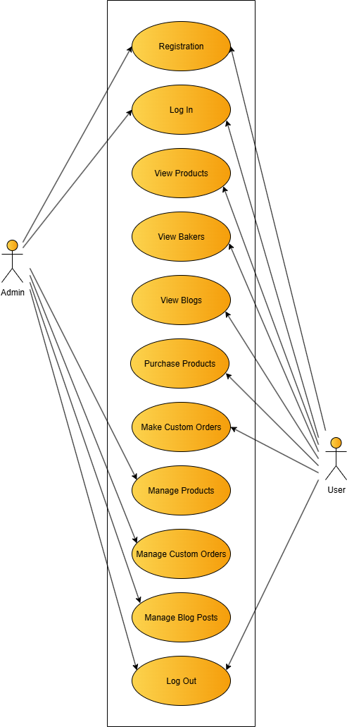**USECASE DIAGRAM**
    2. **ACTIVITY DIAGRAMS**

BAKER SIDE

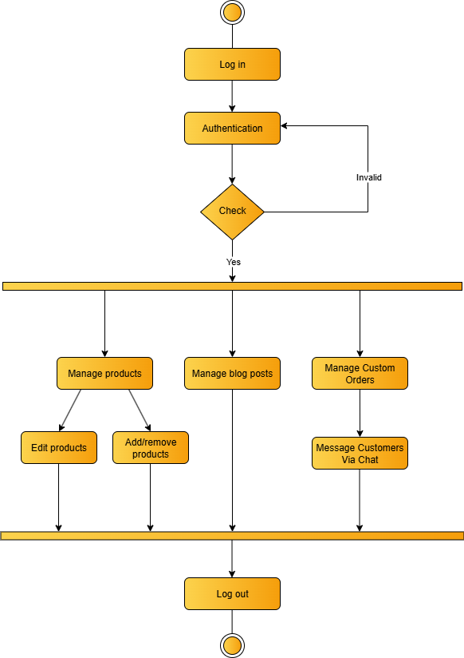

CUSTOMER SIDE

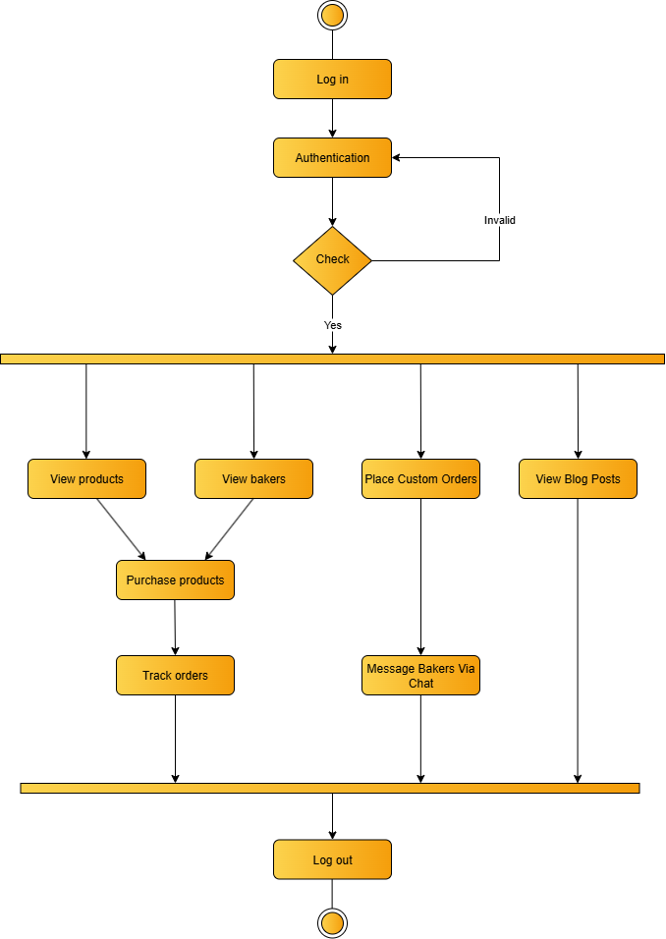

## MODULE DETAILS

There are mainly 7 modules in this website:

* **Login Module**
* **Sign-Up Module**
* **Product Discovery Module**
* **Baker Discovery Module**
* **Blog Discovery Module**
* **Custom Order Module**
* **Admin Dashboard**

1. **Login Module**

The login module allows registered users and administrators to securely access the BakeJourney website. It verifies user credentials (email and password) to grant access to personalized services such as browsing products, purchasing products, and managing custom orders.

1. **Sign-Up Module**

The sign-up module enables new customers to create accounts on BakeJourney. Customers provide personal details including name, email, phone number, and password to register and access features like favouriting products, tracking orders, and placing custom orders.

1. **Product Discovery Module**

The product discovery module allows customers to explore delicious home-baked goods and search for products offered on BakeJourney. Customers can view detailed product information, and add items to their virtual shopping cart for purchase.

1. **Baker Discovery Module**

The baker discovery module enables customers to discover home bakers that understand and meet their unique needs. Customers can find highly specific products by choosing bakers with the right specialty.

1. **Blog Discovery Module**

The blog discovery module allows customers to discover and read blogs posts made by bakers. Customers can explore tips, recipes, stories, and announcements.

1. **Custom Order Module**

Customers can send custom orders specifying their unique requirements for a product through BakeJourney, after which they receive a confirmation or rejection of their request from the respective admin (baker).

1. **Admin Dashboard**

The admin dashboard module provides administrators with tools to oversee custom orders along with their schedules, update website content, and manage their clients. Bakers can ensure smooth platform operation and maintain data integrity.

## PERFORMANCE CONSIDERATIONS

**Hardware Requirements**

The system is designed to perform optimally with a minimum of 4GB RAM and is compatible with Windows OS versions and higher.

## SECURITY CONSIDERATIONS

**Access Control**

* **Authorized Access**: Only customers with valid usernames and passwords are allowed to access the BakeJourney platform.
* **Login Security**: The login process includes robust security measures to authenticate customers and prevent unauthorized access.

## TABLE DESIGN

1. **Table name: users**

|  |  |  |  |  |
| --- | --- | --- | --- | --- |
| **SL.NO.** | **Field Name** | **Data Type** | **Constraint** | **Description** |
| 1. | user_id | int() | Primary Key, Auto_Increment,  Not null | User ID |
| 2. | full_name | varchar(100) | Not null | Full name of user |
| 3. | phone | varchar(15) | Not null | Phone number of user |
| 4. | email | varchar(100) | Not null, Unique | Email address of user |
| 5. | password | text | Not null | Password of user |
| 6. | role | enum(‘customer’, ‘baker’) | Not null | Role specifying user or admin |
| 7. | profile_image | longblob | Null | Profile image of user |
| 8. | bio | text | Null | Bio of user |
| 9. | state | varchar(100) | Null | State of user |
| 10. | district | varchar(100) | Null | District of user |
| 11. | address | text | Null | Address of user |
| 12. | created_at | timestamp | Not null, Default current_timestamp | Date of account creation |

1. **Table name: bakers**

|  |  |  |  |  |
| --- | --- | --- | --- | --- |
| **SL.NO.** | **Field Name** | **Data Type** | **Constraint** | **Description** |
| 1. | baker_id | int() | Primary Key, Auto_Increment, Not null | Baker ID |
| 2. | user_id | int() | Foreign Key, Not null | User ID |
| 3. | brand_name | varchar(255) | Null | Brand name |
| 4. | brand_proof | varchar(255) | Null | Proof of brand registration |
| 5. | identity_proof | varchar(255) | Not null | Proof identity |
| 6. | specialty | varchar(100) | Null | Baker specialty |
| 7. | experience | int() | Not null | Years of Experience |
| 8. | order_lead_time | varchar(100) | Null | Time taken to complete an order |
| 9. | availability | varchar(100) | Null | Status of availability |
| 10. | custom_orders | varchar(100) | Not null | Status of undertaking custom orders |

1. **Table name: products**

|  |  |  |  |  |
| --- | --- | --- | --- | --- |
| **SL.NO.** | **Field Name** | **Data Type** | **Constraint** | **Description** |
| 1. | product_id | int() | Primary Key, Auto_Increment, Not null | Product ID |
| 2. | baker_id | int() | Foreign key, Not null | User (baker) ID of creator |
| 3. | name | varchar(100) | Not null | Name of user |
| 4. | description | text | Not null | Description of product |
| 5. | category | varchar(100) | Not null | Category of product |
| 6. | price | int() | Not null | Price of product |
| 7. | image | varchar(255) | Null | Image of product |
| 8. | weight | decimal(10, 2) | Not null | Weight of product |
| 9. | created_at | date | Not null | Date of creation |

1. **Table name: orders**

|  |  |  |  |  |
| --- | --- | --- | --- | --- |
| **SL.NO.** | **Field Name** | **Data Type** | **Constraint** | **Description** |
| 1. | order_id | int() | Primary Key, Auto_Increment,  Not null | Order ID |
| 2. | customer_id | int() | Foreign Key, Not null | Customer (user) ID |
| 3. | baker_id | int() | Foreign Key, Not null | Baker (admin) ID |
| 4. | delivery_address | text | Not null | Delivery address of customer |
| 5. | delivery_date | datetime | Not null | Date of delivery |
| 6. | order_status | enum | Default ‘pending’ | Order status |
| 7. | total_amount | decimal(10, 2) | Not null | Amount paid for the entire order |
| 8. | payment_method | enum | Not null | Method of payment |
| 9. | payment_status | enum | Default ‘pending | Status of payment |

1. **Table name: order_items**

|  |  |  |  |  |
| --- | --- | --- | --- | --- |
| **SL.NO.** | **Field Name** | **Data Type** | **Constraint** | **Description** |
| 1. | order_item_id | int() | Primary Key, Auto_Increment,  Not null | Order item ID |
| 2. | order_id | int() | Foreign Key, Not null | Order ID |
| 3. | product_id | int() | Foreign Key, Not null | Customer (user) ID |
| 4. | quantity | int() | Not null | Quantity of order item |
| 5. | price | decimal(10, 2) | Not null | Price at time of order |

1. **Table name: cart**

|  |  |  |  |  |
| --- | --- | --- | --- | --- |
| **SL.NO.** | **Field Name** | **Data Type** | **Constraint** | **Description** |
| 1. | cart_id | int() | Primary Key, Auto_Increment,  Not null | Cart ID |
| 2. | user_id | int() | Foreign Key, Not null | User ID |
| 3. | product_id | int() | Foreign Key, Not null | Product ID |
| 4. | quantity | int() | Default 1 | Quantity of products |
| 5. | added_at | timestamp | Default current_timestamp | Time of adding to cart |

1. **Table name: feedback**

|  |  |  |  |  |
| --- | --- | --- | --- | --- |
| **SL.NO.** | **Field Name** | **Data Type** | **Constraint** | **Description** |
| 1. | feedbackid | int() | Primary Key, Auto_Increment, Not null | Feedback ID |
| 2. | name | varchar(100) | Not null | Name of user |
| 3. | email | varchar(100) | Not null | Email of user |
| 4. | subject | varchar(500) | Not null | Feedback subject |
| 5. | message | text | Not null | Feedback content |
| 6. | created_at | time | Not null | Time of submission |

1. **Table name: messages**

|  |  |  |  |  |
| --- | --- | --- | --- | --- |
| **SL.NO.** | **Field Name** | **Data Type** | **Constraint** | **Description** |
| 1. | message_id | int() | Primary Key, Auto_Increment,  Not null | Message ID |
| 2. | sender_id | int() | Foreign Key, Not null | Sender (user) ID |
| 3. | receiver_id | int() | Foreign Key, Not null | Receiver (Admin) ID |
| 4. | message | text | Not null | Message from sender |
| 5. | attachment | varchar(255) | Null | Image attachment with message |
| 6. | sent_at | timestamp | Default current_timestamp | Date and time of message sent |
| 7. | received_at | timestamp | Default current_timestamp | Date and time of message received |

1. **Table name: bank_accounts**

|  |  |  |  |  |
| --- | --- | --- | --- | --- |
| **SL.NO.** | **Field Name** | **Data Type** | **Constraint** | **Description** |
| 1. | id | int() | Primary Key, Auto_Increment,  Not null | Account ID |
| 2. | user_id | int() | Foreign Key, Not null | User ID |
| 3. | accno | varchar(20) | Not null | Account number |
| 4. | ifsc | varchar(11) | Not null | IFSC code |
| 5. | cardno | varchar(16) | Not null | Card number |
| 6. | holder_name | varchar(100) | Not null | Account holder name |
| 7. | cvv | char(3) | Not null | CVV of card |
| 8. | exp_date | date | Not null | Expiry date of card |
| 9. | balance | decimal(15, 2) | Null | Balance amount |

1. **Table name: reviews**

|  |  |  |  |  |
| --- | --- | --- | --- | --- |
| **SL.NO.** | **Field Name** | **Data Type** | **Constraint** | **Description** |
| 1. | review_id | int() | Primary Key, Auto_Increment,  Not null | Product review ID |
| 2. | product_id | int() | Foreign Key, Not null | Product ID |
| 3. | customer_id | int() | Foreign Key, Not null | Customer (user) ID |
| 4. | rating | int() | Not null, Check (rating between 1 and 5) | Rating (stars) |
| 5. | comments | text | Null | Review content |
| 6. | review_date | timestamp | Default current_timestamp | Date of product review |

1. **Table name: product_likes**

|  |  |  |  |  |
| --- | --- | --- | --- | --- |
| **SL.NO.** | **Field Name** | **Data Type** | **Constraint** | **Description** |
| 1. | like_id | int() | Primary Key, Auto_Increment,  Not null | Follower ID |
| 2. | product_id | int() | Foreign Key, Not null | Product ID |
| 3. | customer_id | int() | Foreign Key, Not null | User ID |
| 4. | liked_at | timestamp | Default current_timestamp | Date of like placed |

1. **Table name: baker_reviews**

|  |  |  |  |  |
| --- | --- | --- | --- | --- |
| **SL.NO.** | **Field Name** | **Data Type** | **Constraint** | **Description** |
| 1. | review_id | int() | Primary Key, Auto_Increment,  Not null | Review ID |
| 2. | baker_id | int() | Foreign Key, Not null | User ID |
| 3. | user_id | int() | Foreign Key, Not null | User ID |
| 4. | rating | float | Not null | Rating (stars) |
| 5. | review_text | text | Null | Review content |
| 6. | review_date | datetime | Default current_timestamp | Date of review |

1. **Table name: blog**

|  |  |  |  |  |
| --- | --- | --- | --- | --- |
| **SL.NO.** | **Field Name** | **Data Type** | **Constraint** | **Description** |
| 1. | blog_id | int() | Primary Key, Auto_Increment,  Not null | Blog ID |
| 2. | user_id | int() | Foreign Key, Not null | User ID |
| 3. | blog_title | varchar(100) | Not null | Title of blog post |
| 4. | content | text | Not null | Rating (stars) |
| 5. | category | varchar(100) | Not null | Review content |
| 6. | read_time | Decimal(10, 2) | Not null | Duration of reading blog post |
| 7. | blog_image | varchar(255) | Null | Image of blog post |
| 8. | created_at | timestamp | Default current_timestamp | Time and date of creation |

1. **Table name: blog_comments**

|  |  |  |  |  |
| --- | --- | --- | --- | --- |
| **SL.NO.** | **Field Name** | **Data Type** | **Constraint** | **Description** |
| 1. | comment_id | int() | Primary Key, Auto_Increment,  Not null | Comment ID |
| 2. | blog_id | int() | Foreign Key, Not null | Blog ID |
| 3. | user_id | int() | Foreign Key, Not null | User ID |
| 4. | comment_text | text | Null | Comment content |
| 5. | comment_date | timestamp | Default current_timestamp | Date of comment posted |

1. **Table name: blog_likes**

|  |  |  |  |  |
| --- | --- | --- | --- | --- |
| **SL.NO.** | **Field Name** | **Data Type** | **Constraint** | **Description** |
| 1. | b_like_id | int() | Primary Key, Auto_Increment,  Not null | Blog post like ID |
| 2. | blog_id | int() | Foreign Key, Not null | Blog ID |
| 3. | user_id | int() | Foreign Key, Not null | User ID |
| 4. | liked_at | timestamp | Default current_timestamp | Date of like placed |

# CODING

1. **CODING**

Coding section is where the magic happens. All the planning and the designing done in the previous sections come to life in this section. After this section can only the programmer enjoy the result of his/her hard work when he/she runs the program for the first time.

## SELECTION OF SOFTWARE

**PHP**

PHP, an acronym for Hypertext Preprocessor, is a versatile server-side scripting language that falls under the broader category of software development. It is widely recognized for its pivotal role in web development and boasts several essential features that make it a preferred choice for building dynamic websites and web applications. Here are some of its key features:

* Open Source
* Database Integration
* Embedded in HTML
* Cross-Platform Compatibility
* Security

**MYSQL**

MySQL is an open-source relational database system, widely used for web development task like data storage, manipulation, and retrieval. It seamlessly integrates into web applications, eliminating the need for complex setup. MySQL is embedded within web development environments, making administrative tasks effortless. It operates as an SQL-based database, storing data in text files on the device. Unlike systems like JDBC, MySQL simplifies data access with its broad range of relational database features. Its features are

* Zero configuration
* Server less
* Stable cross platform database file
* Less memory
* Self-contained
* Transactional

## CODING PHASE

The goal of the coding or programming phase is to translate the design of the system produced during the design phase into code in a given programming language, which can be executed by a computer and that performs the computation specified by the design. The coding phase affects both testing and maintenance profoundly. The coding phase does not affect the structure of the system; it has great impact on the internal structure of modules, which affects the testability of the system. The goal of the coding phase is to produce clear simple programs. The aim is not to reduce the coding effect, but to program in a manner so that testing and maintenance costs are reduced. Programs should not be constructed so that they are easy to write; they should be easy to read and understand. Reading programs is a much more common activity than writing programs. Hence, the goal of the coding phase is to produce simple programs that are clear to understand and modify.

* + 1. **CODING STANDARDS**

The standard used in the development of the system is Microsoft Programming standards. It includes naming conversations of variables, constants and objects, standardized formats for labelling and commenting code, spacing, formatting, and indenting.

**Naming Conventions**

The controls are prefixed to indicate their functions. The frames are prefixed with frm, textboxes are prefixed with txt, command buttons with cmd, label boxes with lbl, list boxes with lst, comboboxes with cmb, Date Time Pickers with DTP, Grid with grid and so on.

**Labels and Comments**

The functions of each control are labelled clearly in the GUI. The code also includes comments so that other developers using the source code in future might understand the module functions better.

# TESTING

# &

# IMPLEMENTATION

1. **TESTING**

Software testing is a critical element of software quality assurance and represents the ultimate review of specifications design and coding. Testing presents an interesting anomaly for the software. Testing is a quality measure process, which reveals the errors in the program. During testing, the program is executed with a set of test cases and the output of the program for the test cases is evaluated to determine if the program is performing as it is expected. Testing plays a very critical role in determining the reliability and efficiency of the software and it is a very important stage in software development.

## TESTING

System testing is actually a series of different tests whose primary purpose is to fully exercise the computer-based systems. Although each test has a different purpose, all work to verify that all system elements have been properly integrated and perform allocated functions. System testing is done in order to ensure that the system developed doesn’t fail at any point. Before implementations, the system is tested with experimental data to ensure that it will meets the specified requirements, special tests data are input for processing and results examined.

* + 1. **TEST PLAN**

Preparation of test data Taking various kinds of test data does the testing. Preparation of test data plays a vital role in the system testing. After preparing, the test data the system under study is tested using that test data. While testing the system by using test data errors are again uncovered and corrected by using above testing steps and correction are also noted for future use. Two kinds of test data were collected and used:

**Using live test data**

Live test is those that are actually extracted from organization files. After a system is partially constructed, programmers or analyst often ask users to key in a set of data form their normal activities. Then, the system person uses this data as a way to partially test the system. In order instance, programmers or analysts extract a set of live data from the files and have entered themselves.

**Using artificial test data**

Artificial test data are created solely for test purpose, since they can be generated to test all combinations of formats and values. In other words, the artificial data, which can quickly be prepared by a data generating utility program in the information system department, make possible the testing of all login and control paths through the program. The most effective test program uses artificial test data generated by person other than those who wrote the program. In this project invalid data was entered to test whether the program would break or not. These invalid data entries were randomly generated using random people. Many people were given the software for testing the program. They use gibberish values to test if every validation holds strong.

## TESTING METHODS

Testing is generally done at two levels-testing of individual modules and testing of the entire system. During system testing, the system is used experimentally to ensure that the software does not fail that is, that it will run according to its specifications and the results examined. A limited number of uses may be allowed to use the system so analysis can see whether they use it in unforeseen ways. It is preferable to discover any surprise before the organization implements the system and depends on it.

Testing is done throughout system development at various stages. It is always a good practice to test the system at many different levels at various intervals, that is, sub systems, program modules as work progresses and finally the system as a whole. During testing the major activities are concentrated on the examination ad modification of the source code. Usually, this testing is to be performed by the person other than the person who has really coded it. This is done in order to ensure more complete and unbiased testing for making the software more reliable. There are two types of testing:

* Black box testing
* White box testing
  + 1. **WHITE BOX TESTING**

In white box testing, the internal logic of the modules is considered. Following levels of testing are performed for the developed project:

* + - 1. **Unit Testing**

This involves the tests carried out on modules programs, which make up a system. This is also called as a program testing. The units in a large system many modules at different levels are needed. Unit testing focuses on the modules, independently of one another, to locate errors. The program should be tested for correctness of logic applied and should detect errors in coding. Before proceeding one must make sure that all the programs are working independently.

* + 1. **BLACK BOX TESTING**

The concept of the black box is used to represent a system who’s inside workings are not available for inspection. In a black box, the test item is treated as “black,” since its logic is unknown; all that is known is what goes in and what comes out, or the input and output.

* + - 1. **System Testing**

The system testing is conducted on a complete, integrated system to evaluate the system’s compliance with its specified requirement. It falls within scope of black box testing so no knowledge of inner design or logic is needed. As a rule, system testing takes, as its input, all of the integrated software components that have passed integration testing and also the software system itself integrated with any applicable hardware system. The purpose of the integration testing is to detect any inconsistencies between software units. System testing is the stage of implementation, which is aimed at ensuring that the system works accurately and efficiently before live operation commence. The logical design and the physical design should be thoroughly and continually examined on paper ensure that they will work when implemented.

* + - 1. **Integration Testing**

Integration testing is a systematic technique for constructing the program structure, while at the same time conducting tests to uncover errors associated with interfacing. This is the program that is constructed and tested in small segments, which makes it easier to isolate. The following common types of integration problems may be:

* Version mistakes
* Data integrity violations
* Overlapping function
* Resource problems especially in memory handling
* Wrong type of parameter in function calls
  + - 1. **Validation Testing**

At the culmination of the integration testing, the software was completely assembled as a package, interfacing errors have been uncovered and corrected and a final series of software validation testing began. In validation testing we test the system functions in a manner that can be reasonably expected by customer, the system was tested against system requirement specification. Different unusual inputs that the users may use were assumed and the outputs were verified for such unprecedented inputs. Deviation or errors discovered at this step are corrected prior to the completion of this project with the help of user by negotiating to establish a method for resolving deficiencies. Thus, the proposed system under consideration has been tested by using validation testing and found to be working satisfactorily. Validation checking is performed on the:

* **Numeric Field:** The numeric field can contain only numbers from 0 to 9. An entry of any character flashes an error message. The individual modules are checked for accuracy and what it has to perform. Each module is subjected to test run along with sample data. The individually tested module is integrated into a single system.
* **Character Field:** This field can only contain letters from A-Z and a-z. It is useful for name, address fields and so on.
* **Check Null Fields:** Before entering values into the database or when updating, a validation is done to check whether any NULL fields are present.
* **Email Fields:** An email only field with a limit of characters. All the necessary validation checks were verified to see if invalid data ever enters into the database. Null values in fields were also treated as invalid values.
* **Password Fields:** A password only field with a limit of characters. All the necessary validation checks were verified to see if invalid data ever enters into the database. Null values in fields were also treated as invalid values.
  + 1. **OUTPUT TESTING**

After performing validation test, the next phase is output test of the system, since no system could be useful if it does not produce the desired output in the desired format. By consideration the format of the report/output was generated or displayed and was tested. Here output format was considered in one way: on the display screen.

* + 1. **USER ACCEPTANCE TESTING**

User acceptance testing is the key factor for the success of a system. The system under consideration was listed for user acceptance by maintaining constant contact with the perspective user of the system at the time of design, development and making changes whenever required. This was done with regards to the following points:

* Input screen design
* Output design

Users from each of the 2 user types (Baker, Customer) were selected for user acceptance testing. The Baker (admin) was given the software for testing with their username and password. The admin actions were performed and then observed to see whether all details were populating in the database and working as expected. The customer’s side was tested using a customer name and password by registering to the system and seeing whether they can use the system’s functionalities as expected.

## IMPLEMENTATION

Implementation is the stage of the project when the theoretical design is turned into a working system. The implementation stage is a system project in its own right. It includes careful planning, investigation of current system and its constraints on implementation, design of methods to achieve the changeover, training of the staff in the changeover procedure and evaluation of the changeover method.

The first task in implementation is planning deciding on the methods and time scale to be adopted. Once the planning has been completed the major effort is to ensure that the programs in the system are working properly when the user has been trained.

The complete system involving both computer and user can be executed effectively. Thus, the clear plans are prepared for the activities.

Successful implementation of the new system design is a critical phase in the system life cycle. Implementation means the process of converting a new or a revised system design into an operational one.

# MAINTENANCE

# &

# ENHANCEMENT

1. **MAINTENANCE AND ENHANCEMENT**

## MAINTENANCE

This software can be modified as need occurs. Maintenance includes all the activities after installation of the software that is performed to keep the system operational. The process of maintenance involves:

* Understanding the existing software
* Understand the effect of change
* Test for satisfaction

This software requires little to no maintenance. During the testing phase most maintenance duties are performed. If a maintenance requirement occurs, it can be solved with ease.

## ENHANCEMENT

The BakeJourney website is built with a modular architecture, allowing for easy expansion and additional functionalities. As the business grows and customer demands evolve, the platform can seamlessly integrate new features to enhance the user experience.

Future enhancements to the BakeJourney platform could include:

* **Smart Calendar and Scheduler:** Integrate a smart calendar system with task scheduling and reminders to help bakers keep track of their work efficiently.
* **Smart Analytics:** Offer an analytical system to bakers via graphs, bar charts, and other data analysis formats in order to obtain advanced insights.
* **Third-party Notification System:**
  + Implement SMS or email alerts for bakers to track:
    - upcoming and completed orders
    - product ratings, likes, and reviews
    - ratings and reviews for the baker
  + Implement SMS or email alerts for customers to keep track of new product postings, product updates, blog posts, and order status, helping customers stay up-to-date.
* **Inventory Tracking:** Implement an advanced inventory tracking system to help bakers keep track of their products, ingredients etc.
* **Localized Ingredient Marketplace**
  + Create a curated marketplace where bakers can source ingredients from verified vendors.
  + Include filters for organic, gluten-free, vegan, etc., with price comparisons and delivery options.
* **AI-Powered Recipe Assistant**
  + Suggest recipes based on available inventory, seasonal trends, or customer preferences.
  + Enable bakers to auto-generate ingredient lists, nutritional info, and allergen warnings.
* **Smart Order Forecasting:** Predict demand spikes based on holidays, weather, or local events to help bakers prep inventory and staffing accordingly.
* **Customer Loyalty & Rewards System**
  + Introduce points, badges, or tiered memberships for repeat customers.
  + Offer personalized discounts, early access to new products, or birthday treats.
* **Sustainability Dashboard:** Track eco-friendly practices like packaging choices, waste reduction, and local sourcing. Offer badges or certifications for sustainable bakers.
* **Multi-language & Regional Customization:** Enable bakers to localize their storefronts with regional languages, currencies, and cultural preferences.

These future developments will help enhance BakeJourney’s service offerings, attract new customers, and provide a seamless, user-friendly experience that stays competitive as technology advances.

# CONCLUSION

1. **CONCLUSION**

The BakeJourney project marks a significant stride in bridging the gap between traditional home baking and modern digital entrepreneurship. By offering a user-friendly, scalable, and secure web-based platform, it empowers home bakers to showcase their creations, manage orders efficiently, and engage meaningfully with customers. The system’s modular architecture, intuitive design, and robust backend ensure seamless functionality for both bakers and dessert enthusiasts.

Through comprehensive analysis, design, implementation, and testing phases, BakeJourney demonstrates its operational, technical, and economic feasibility. The platform not only simplifies bakery operations but also fosters community engagement through features like blogs, reviews, and custom orders. Its emphasis on usability, reliability, and scalability makes it a promising tool for supporting local businesses and promoting personalized culinary experiences.

Looking ahead, BakeJourney offers ample scope for enhancement, including smart analytics, inventory tracking, and AI-powered recipe suggestions. These future developments will further elevate the platform’s value, making it a dynamic ecosystem for home bakers and customers alike. In essence, BakeJourney is more than a project. It is a digital journey that celebrates creativity, connection, and the entrepreneurial spirit of home baking.

# BIBLIOGRAPHY

**BIBLIOGRAPHY**

**WEBSITES**

* [Icons8](https://icons8.com/) | [icons8.com](https://icons8.com/)
* [Flaticon](https://www.flaticon.com/) | [www.flaticon.com](http://www.flaticon.com/)
* [Unsplash](https://unsplash.com/) | [unsplash.com](https://unsplash.com/)
* [Pexels](https://www.pexels.com/) | [www.pexels.com](http://www.pexels.com)
* [Google Fonts](https://fonts.google.com/) | [fonts.google.com](https://fonts.google.com/)
* [Storyset](https://storyset.com/) | [storyset.com](https://storyset.com/)
* [Larin Type Co.](https://creativemarket.com/pasha.larin) | [creativemarket.com/pasha.larin](https://creativemarket.com/pasha.larin)
* Material UI | [mui.com/material-ui](https://mui.com/material-ui/)
* Lovable | [lovable.dev](https://lovable.dev/)
* Claude | [claude.ai](https://claude.ai/)

# APPENDIX

**SCREENSHOTS**

**USER MODULE**

1. **LOGIN**

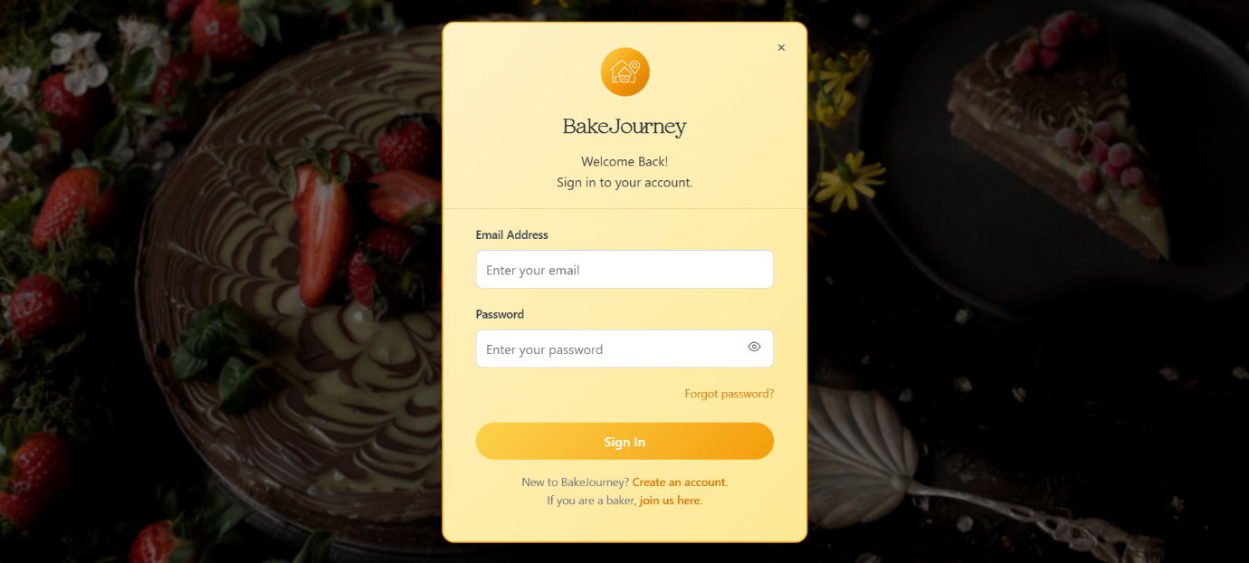

1. **REGISTRATION (SIGN-UP)**

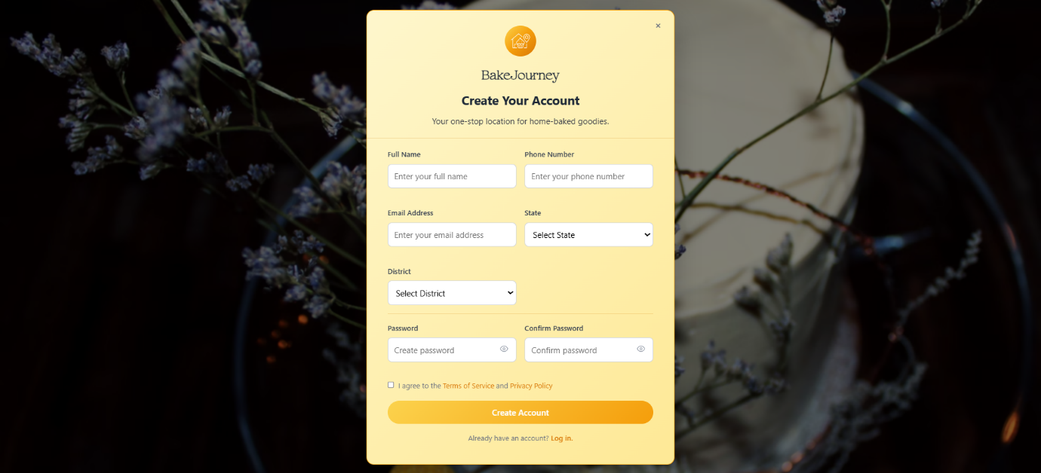

1. **HOME PAGE (DASHBOARD)**

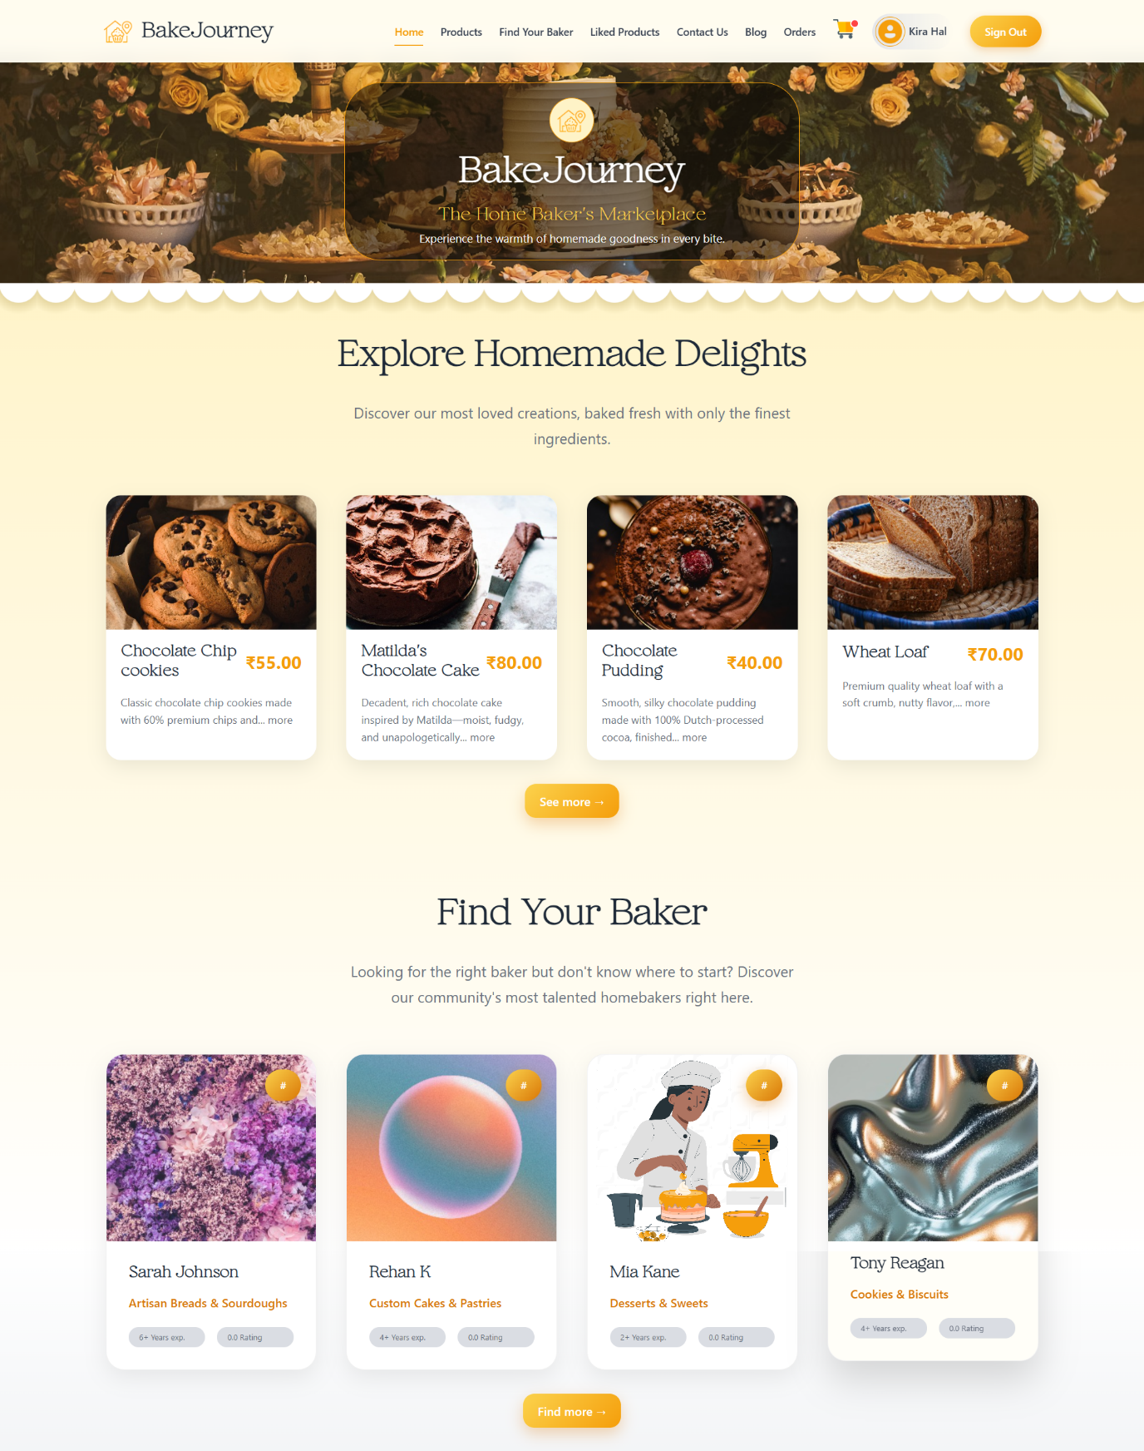

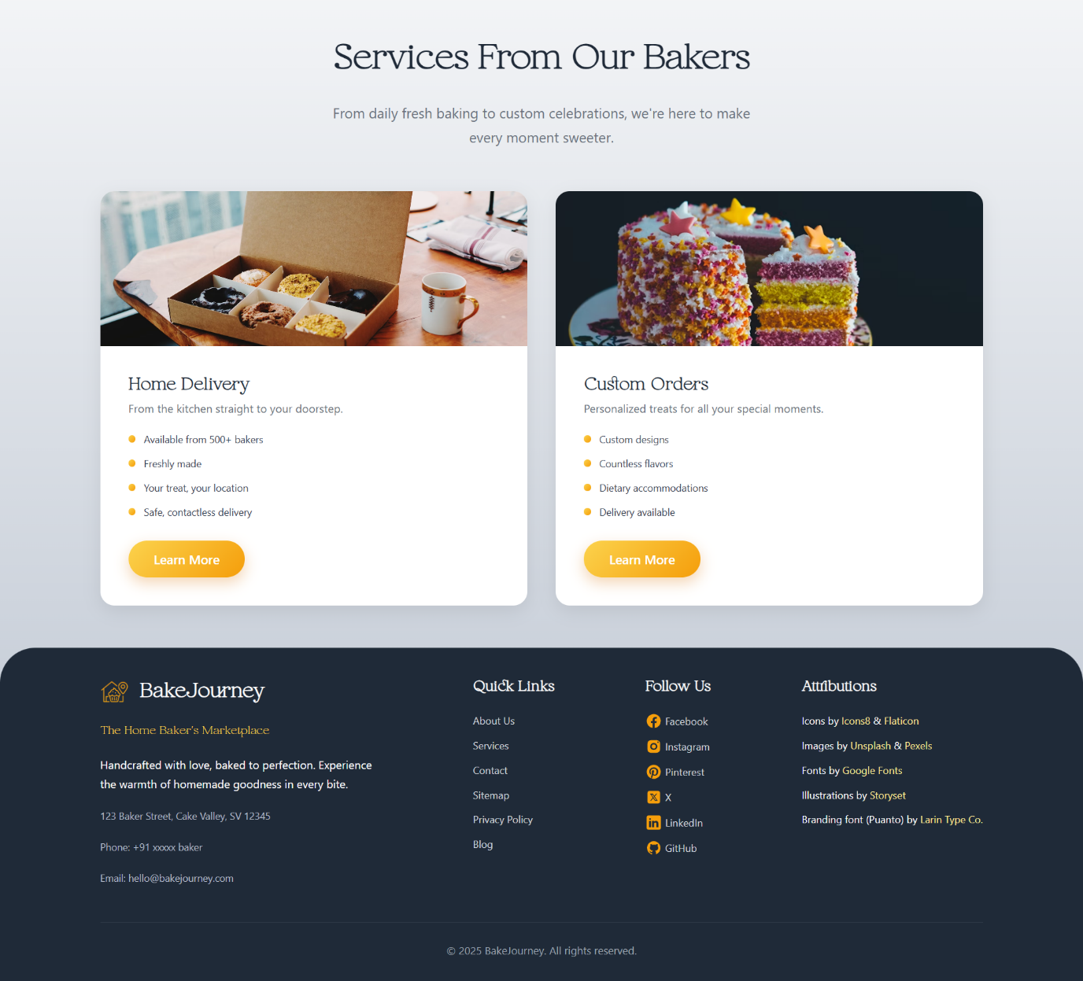

1. **PRODUCTS**

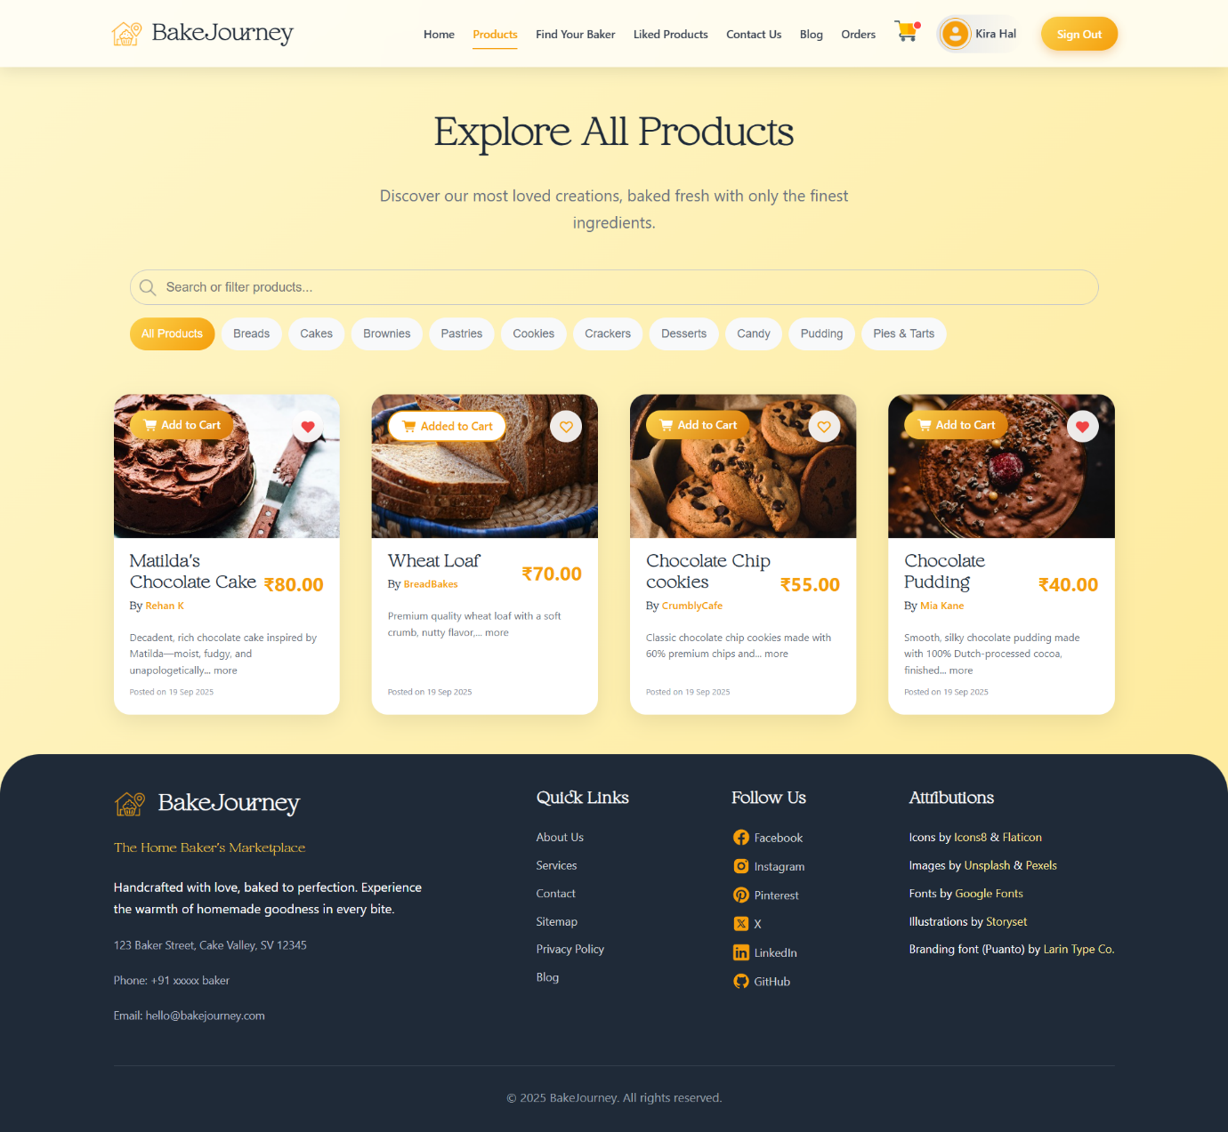

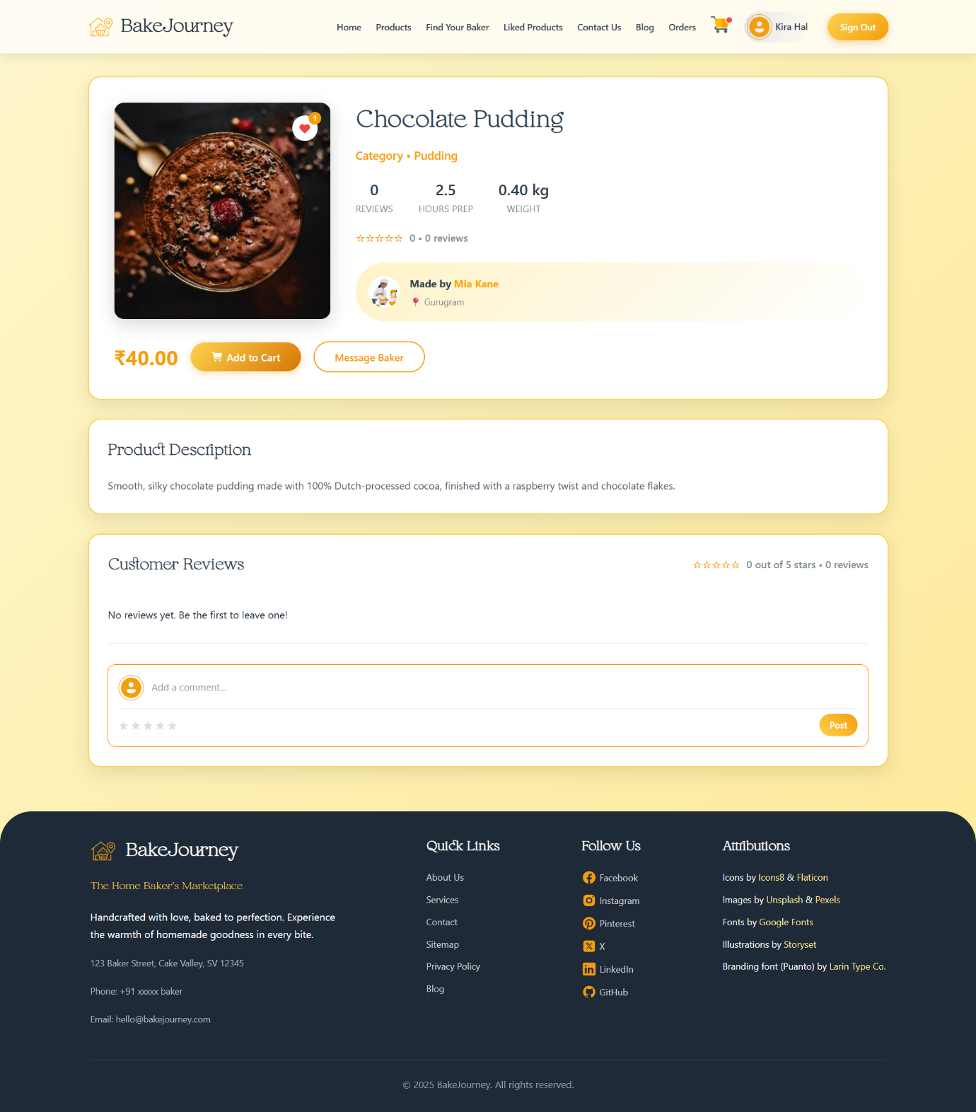

1. **FIND YOUR BAKER**

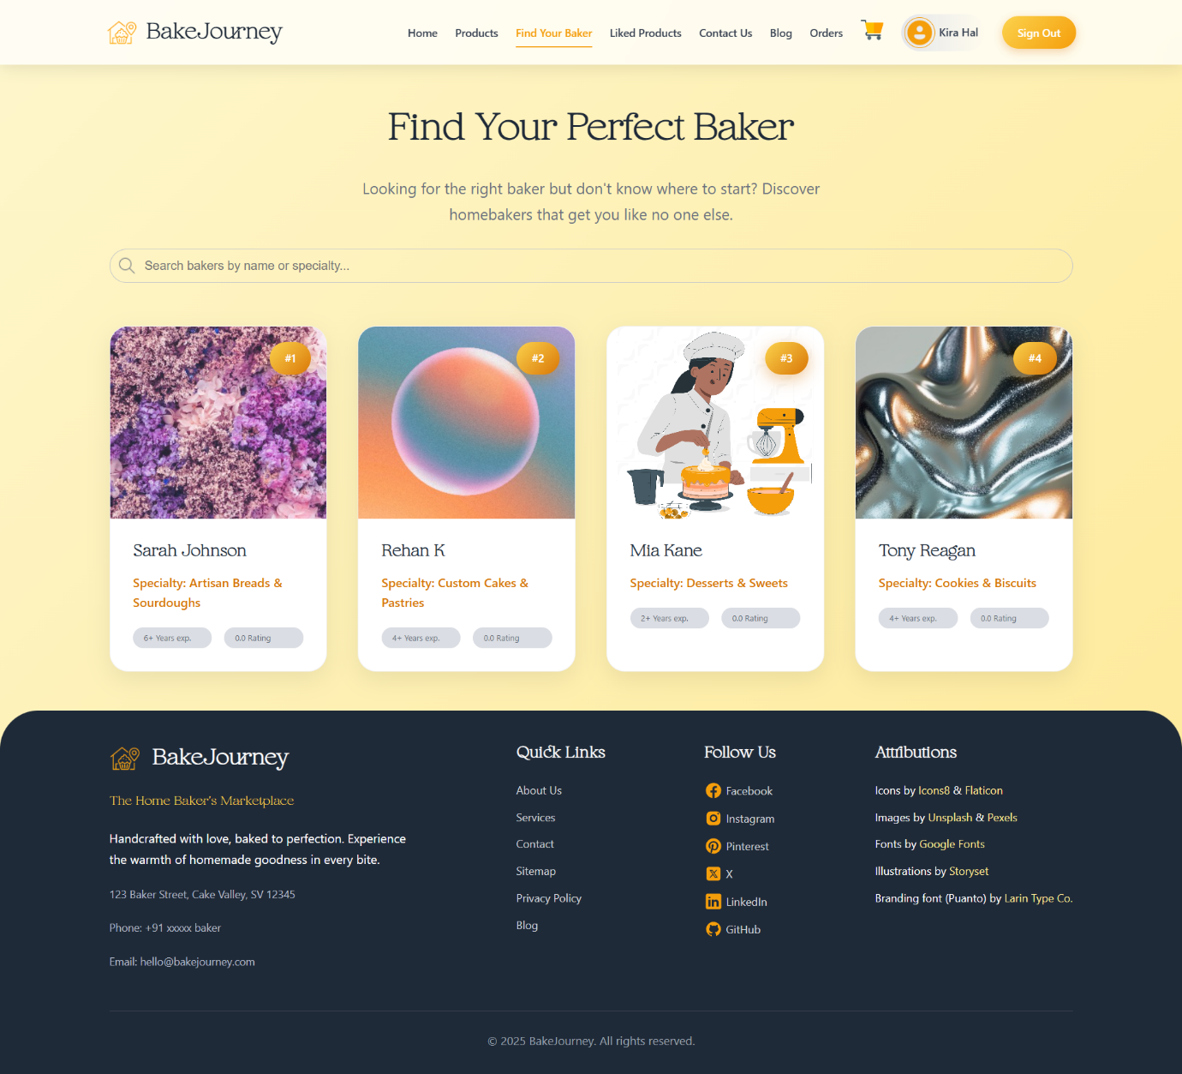

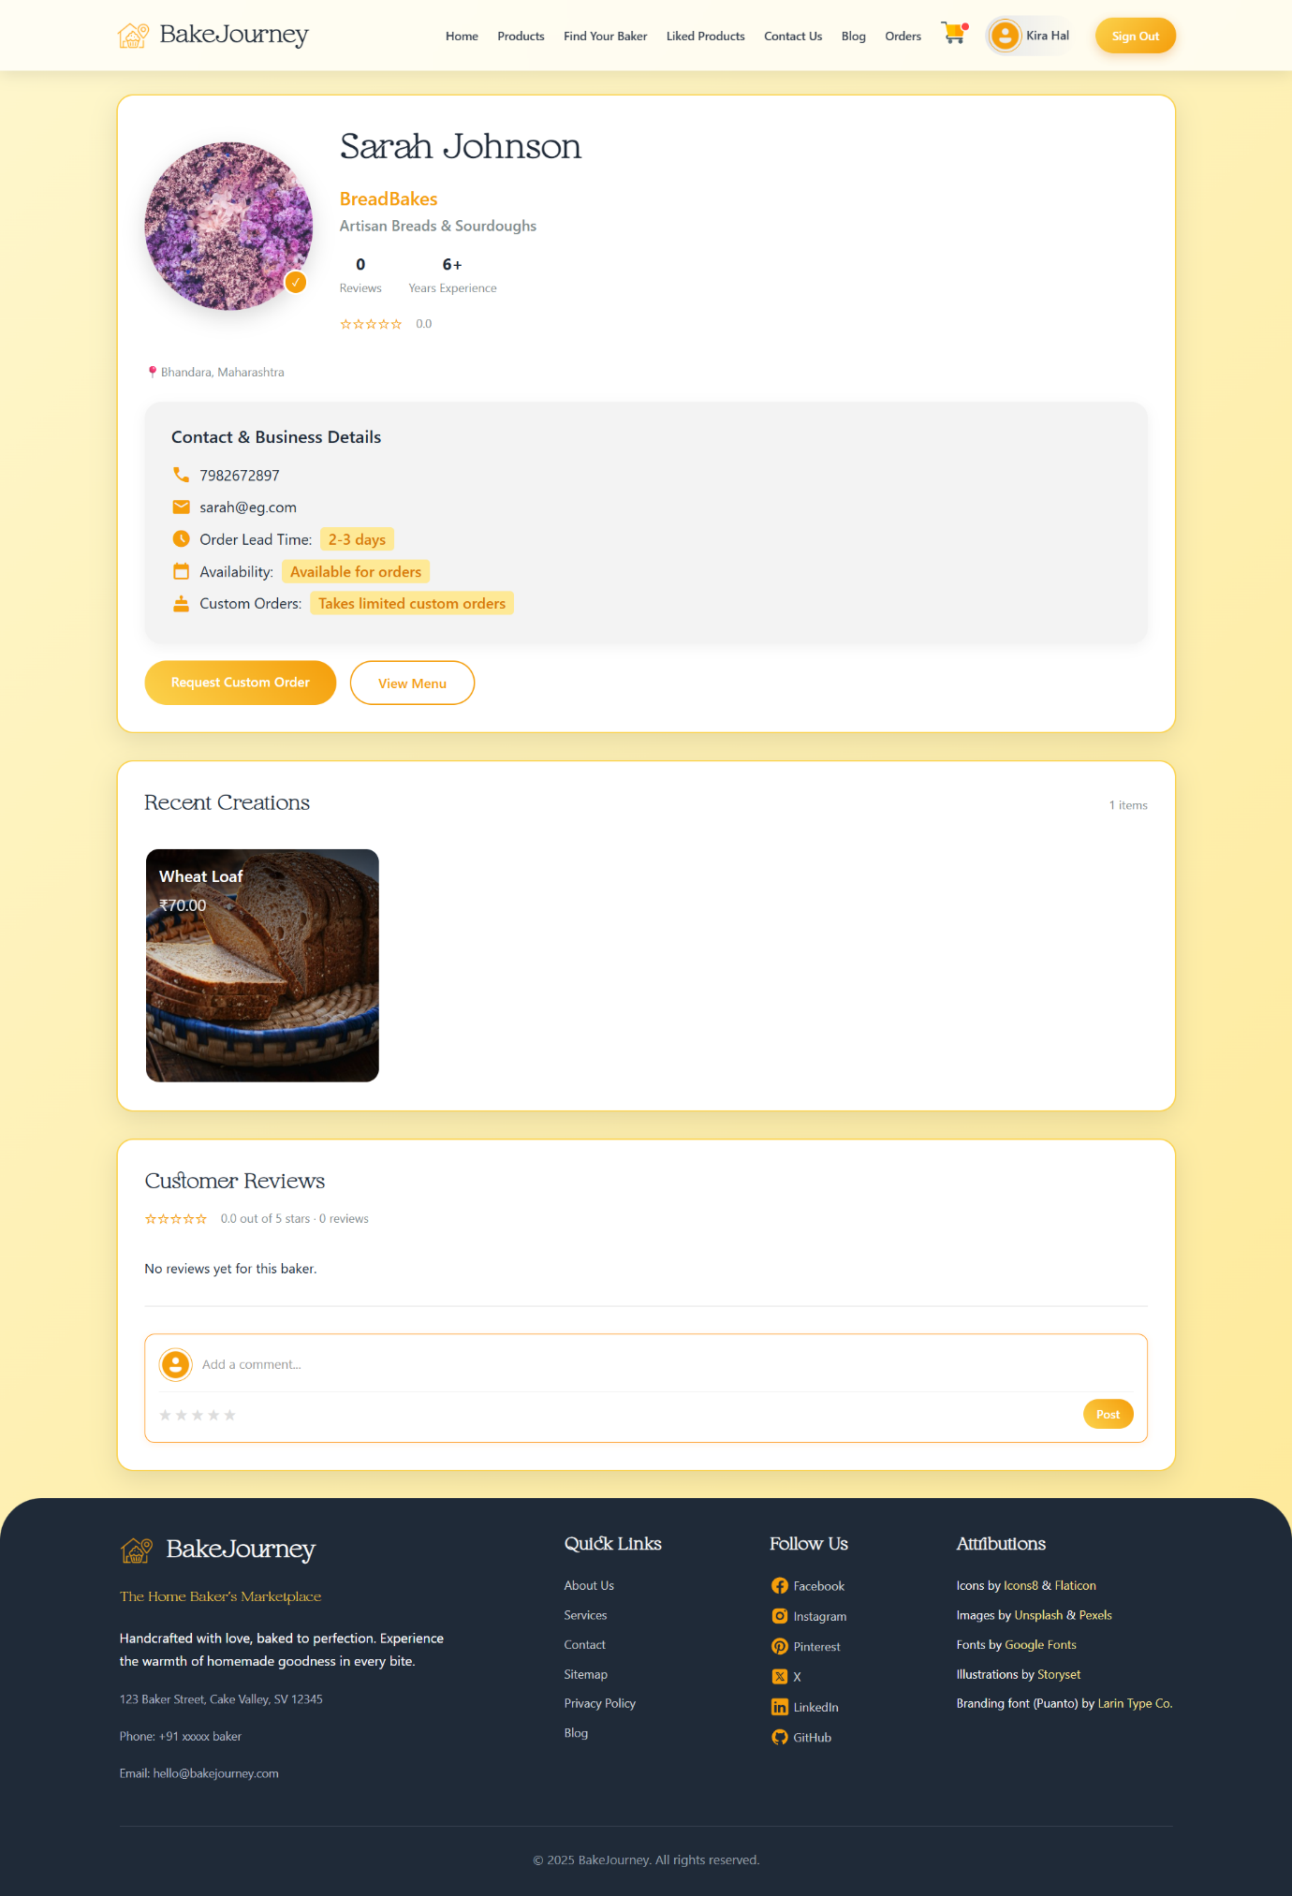

1. **LIKED PRODUCTS**

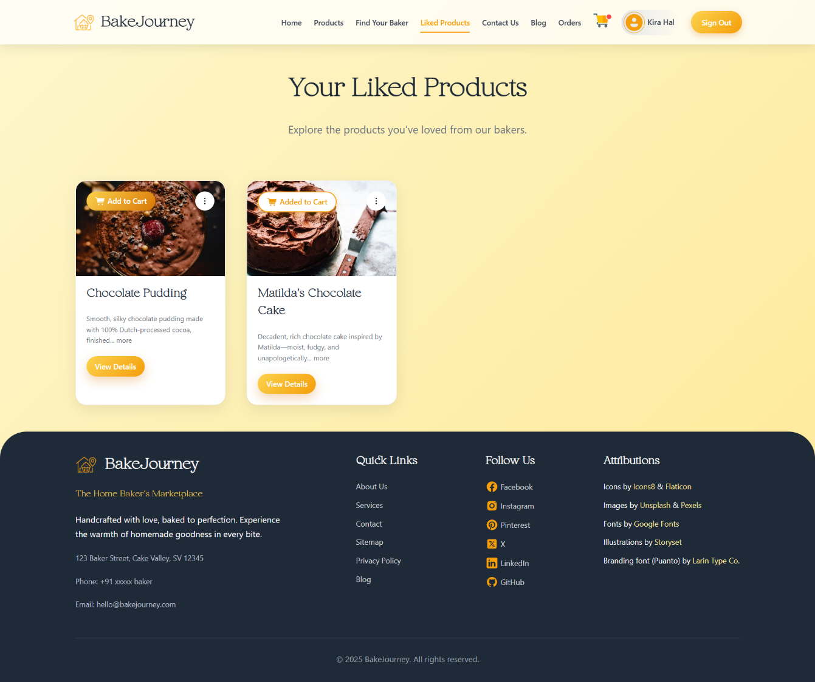

1. **FEEDBACK PAGE**

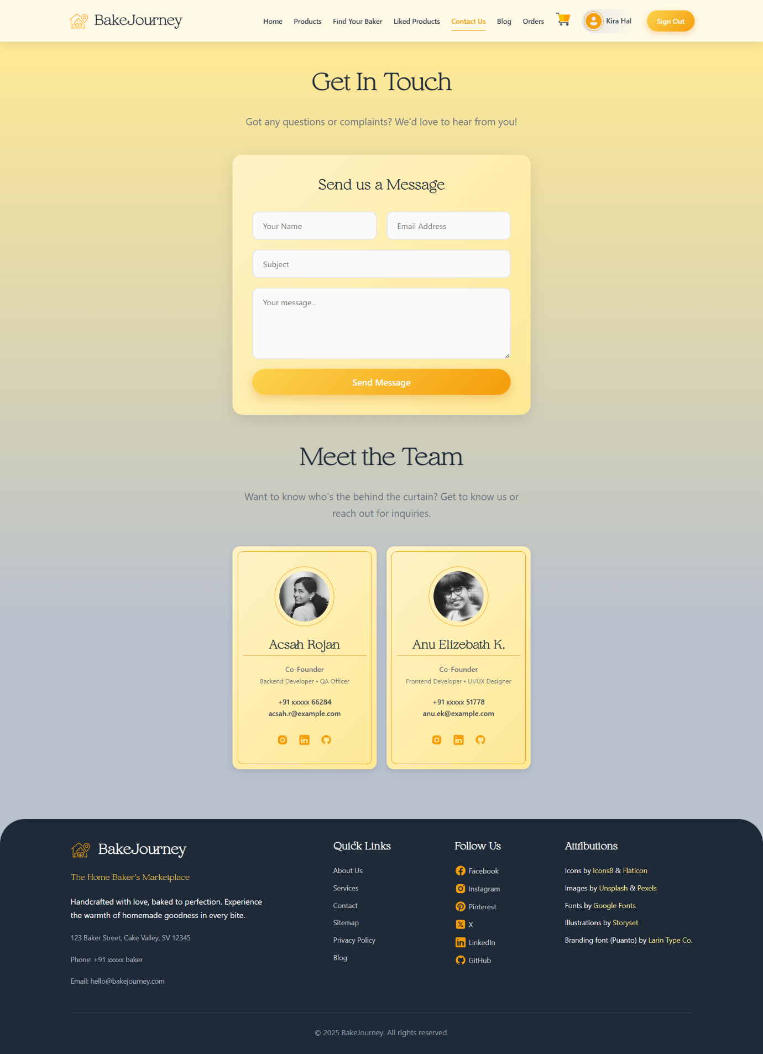

1. **BLOG PAGE**

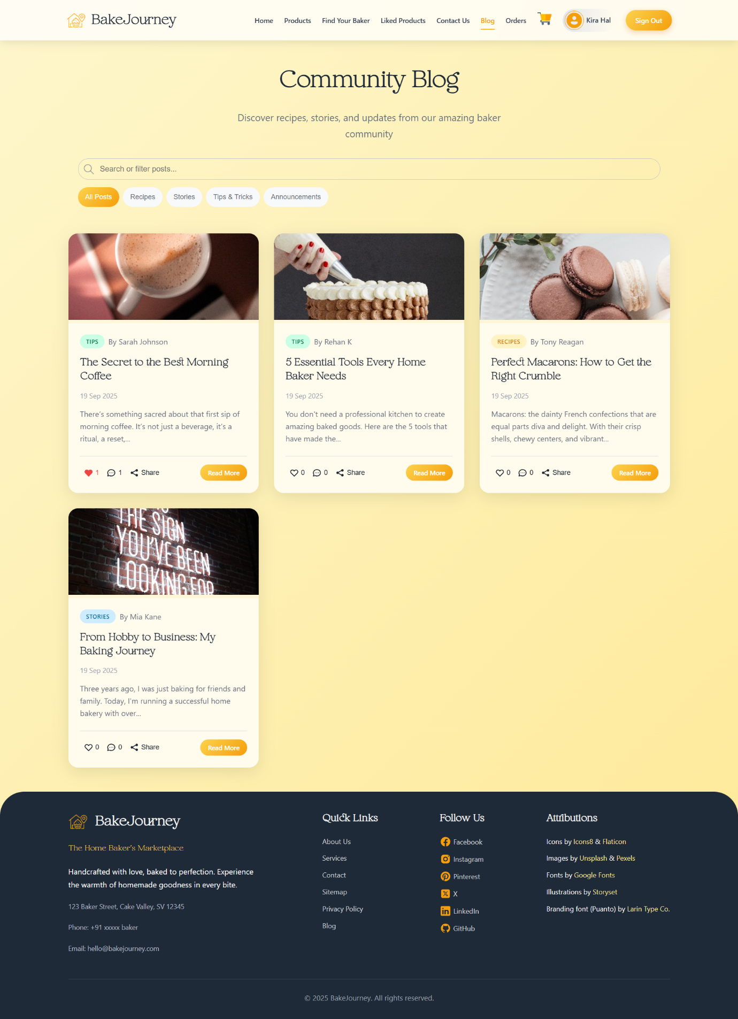

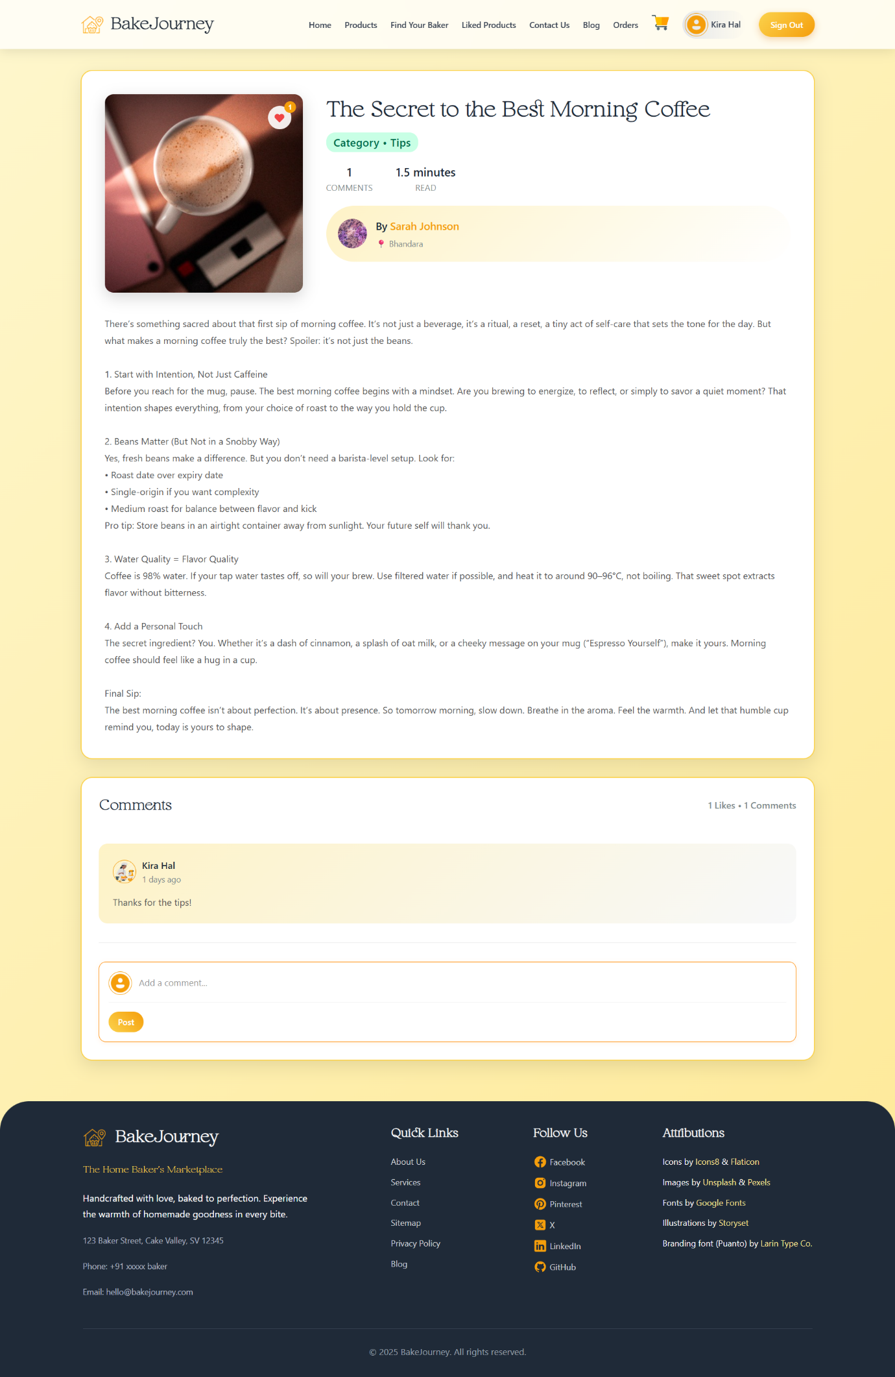

1. **CART PAGE**

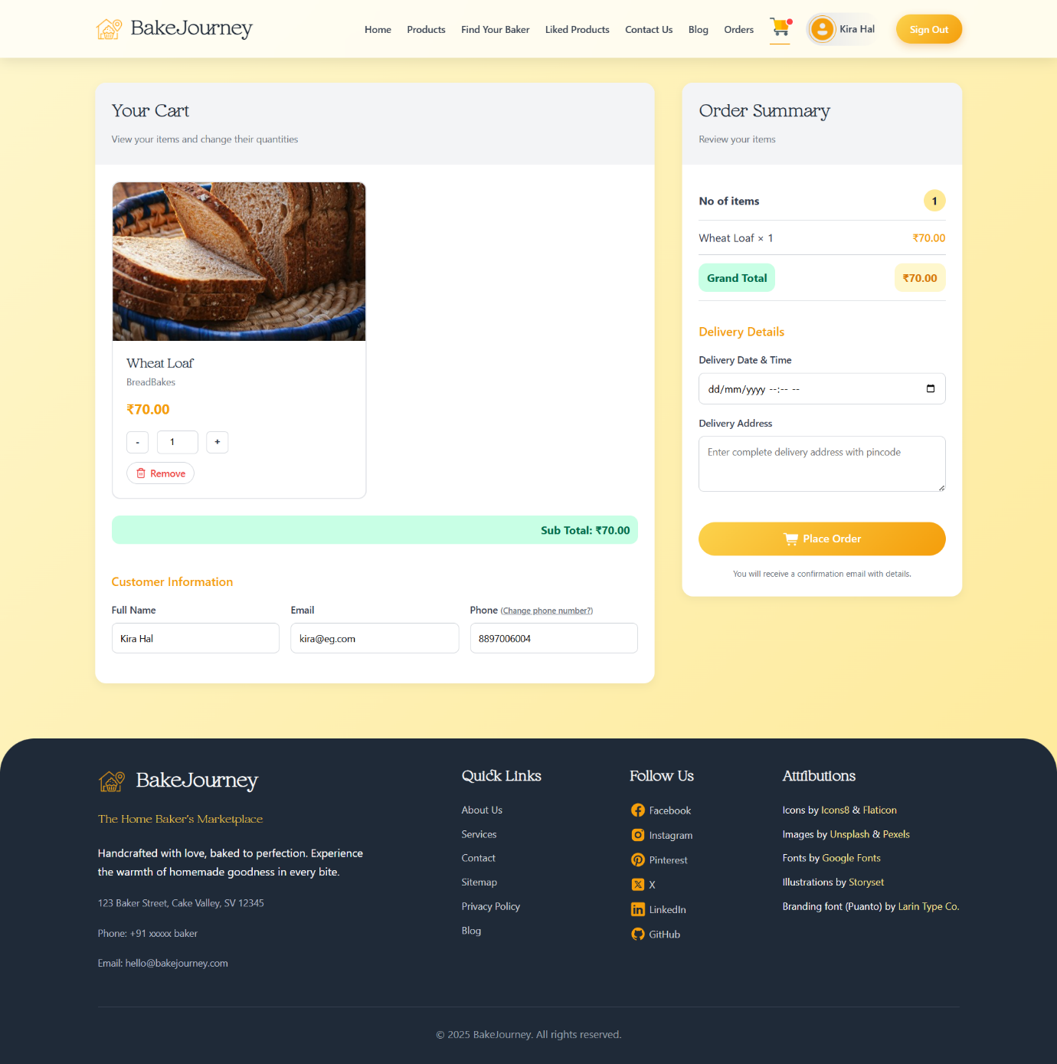

1. **ORDERS PAGE**

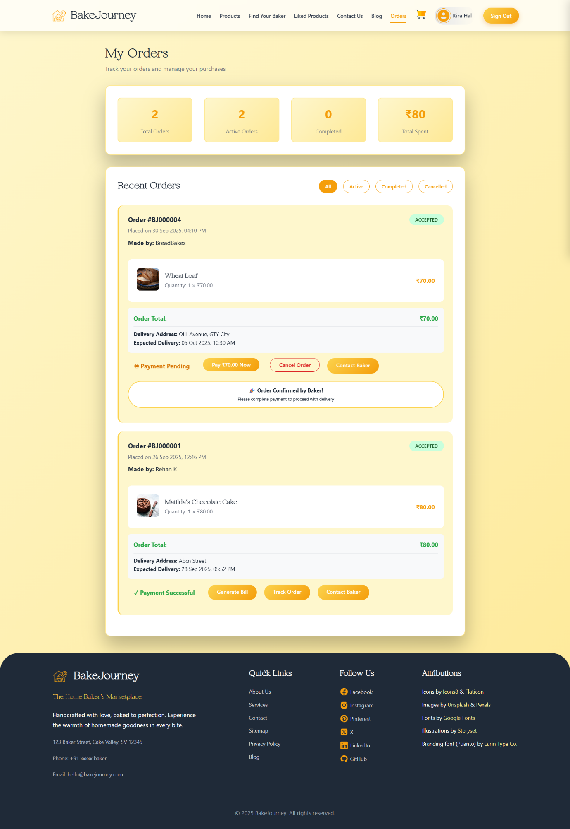

1. **PAYMENTS PAGE**

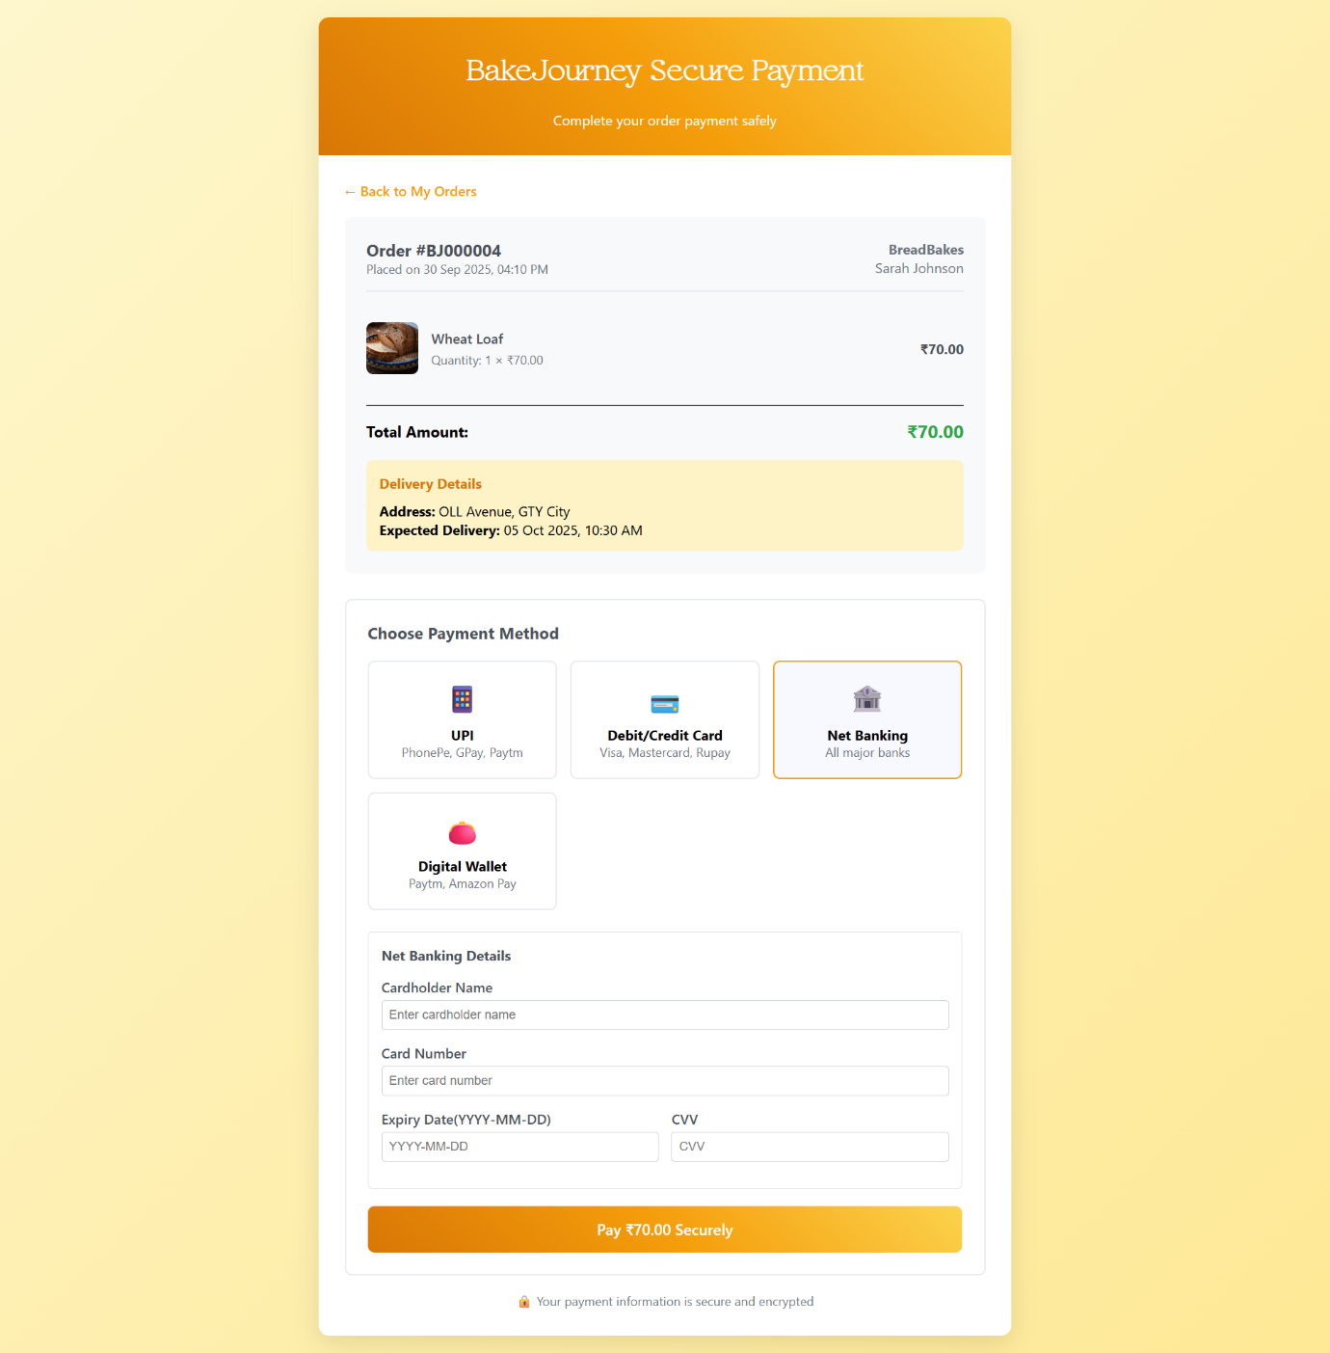

1. **CUSTOM ORDER MESSAGING**

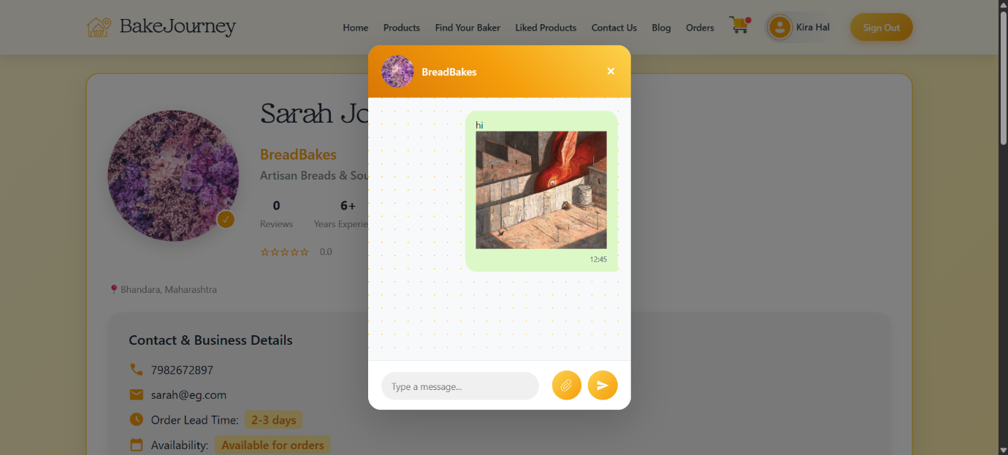

1. **USER PROFILE PAGE**

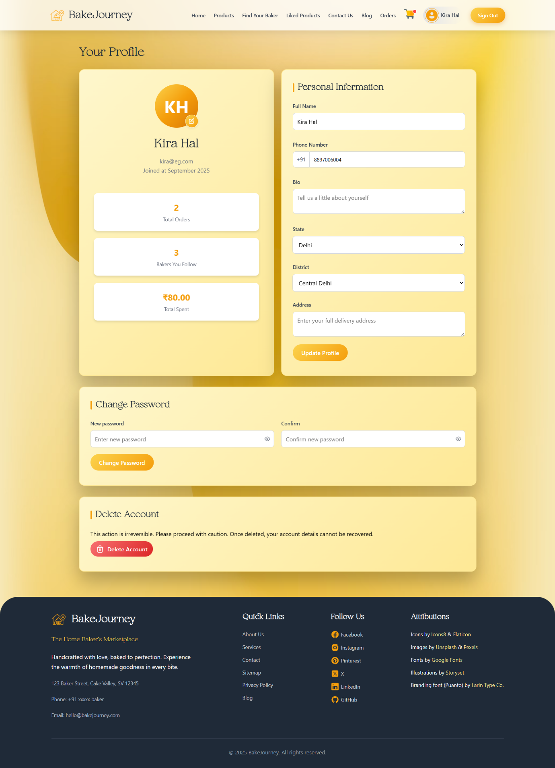

**ADMIN MODULE**

1. **REGISTRATION (SIGN-UP)**

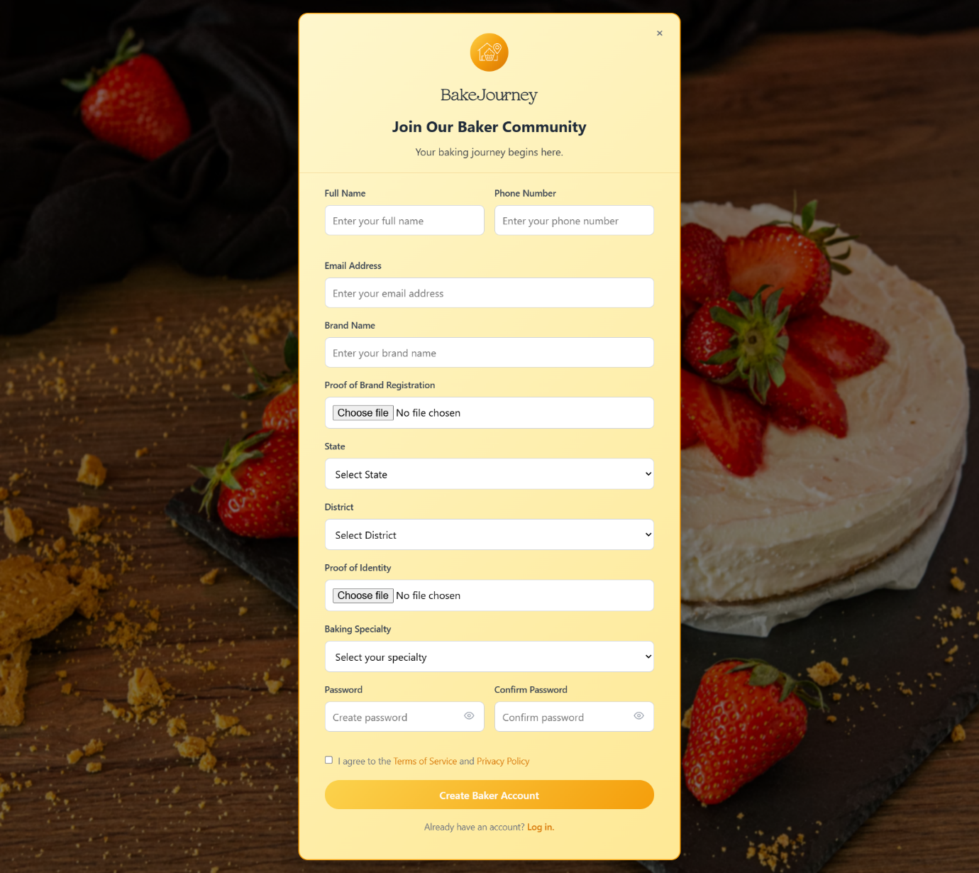

1. **HOME PAGE (DASHBOARD)**

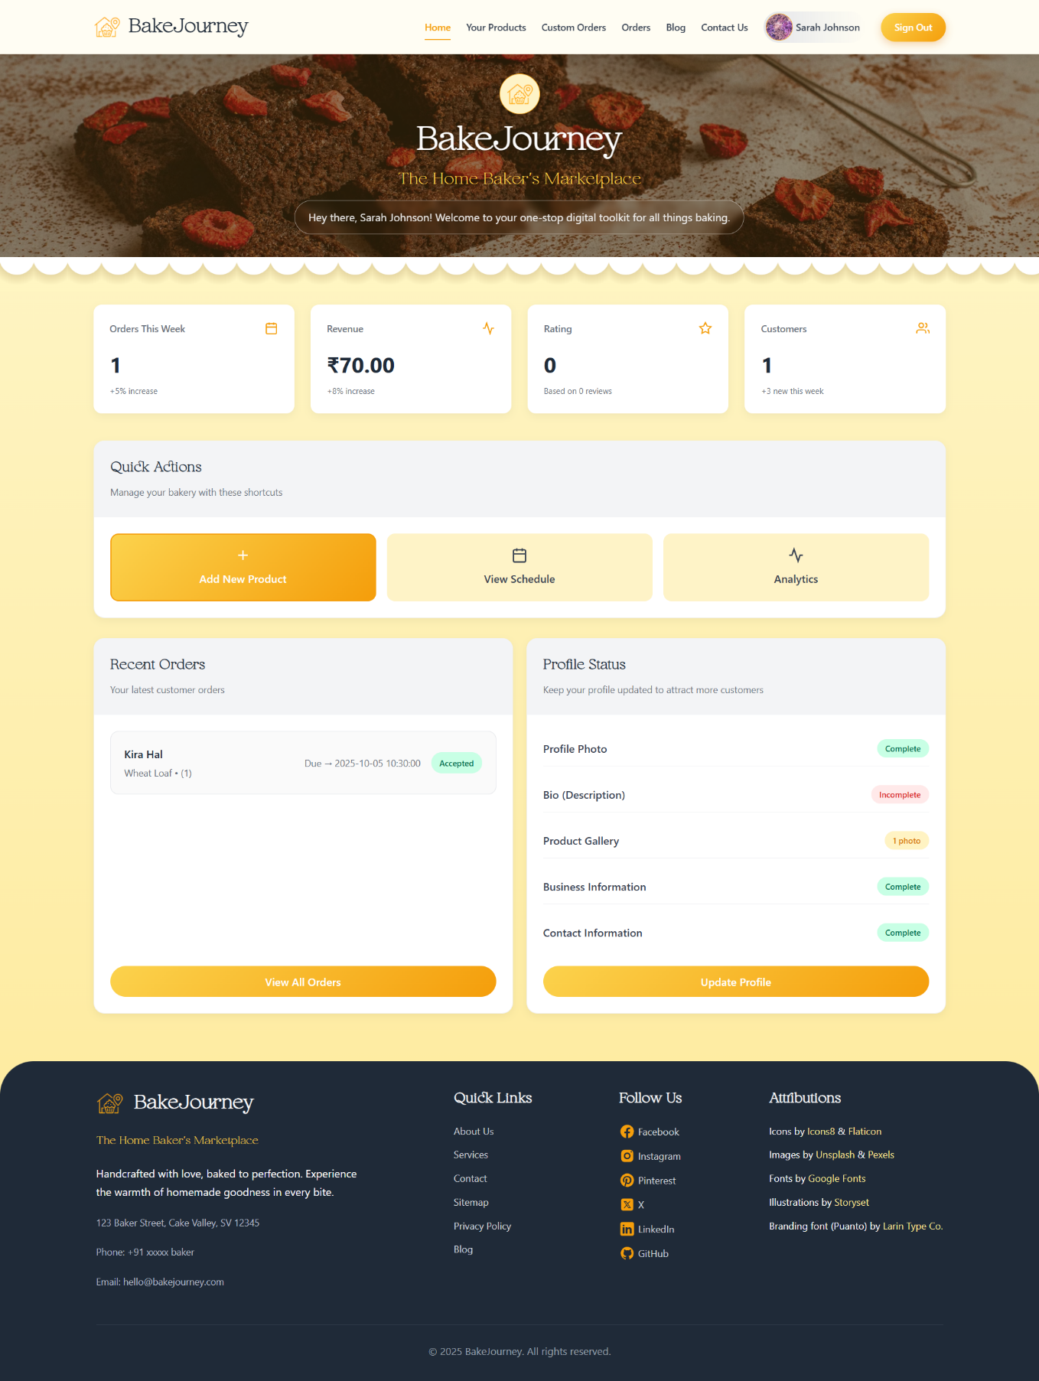

1. **PRODUCTS MANAGEMENT PAGE**

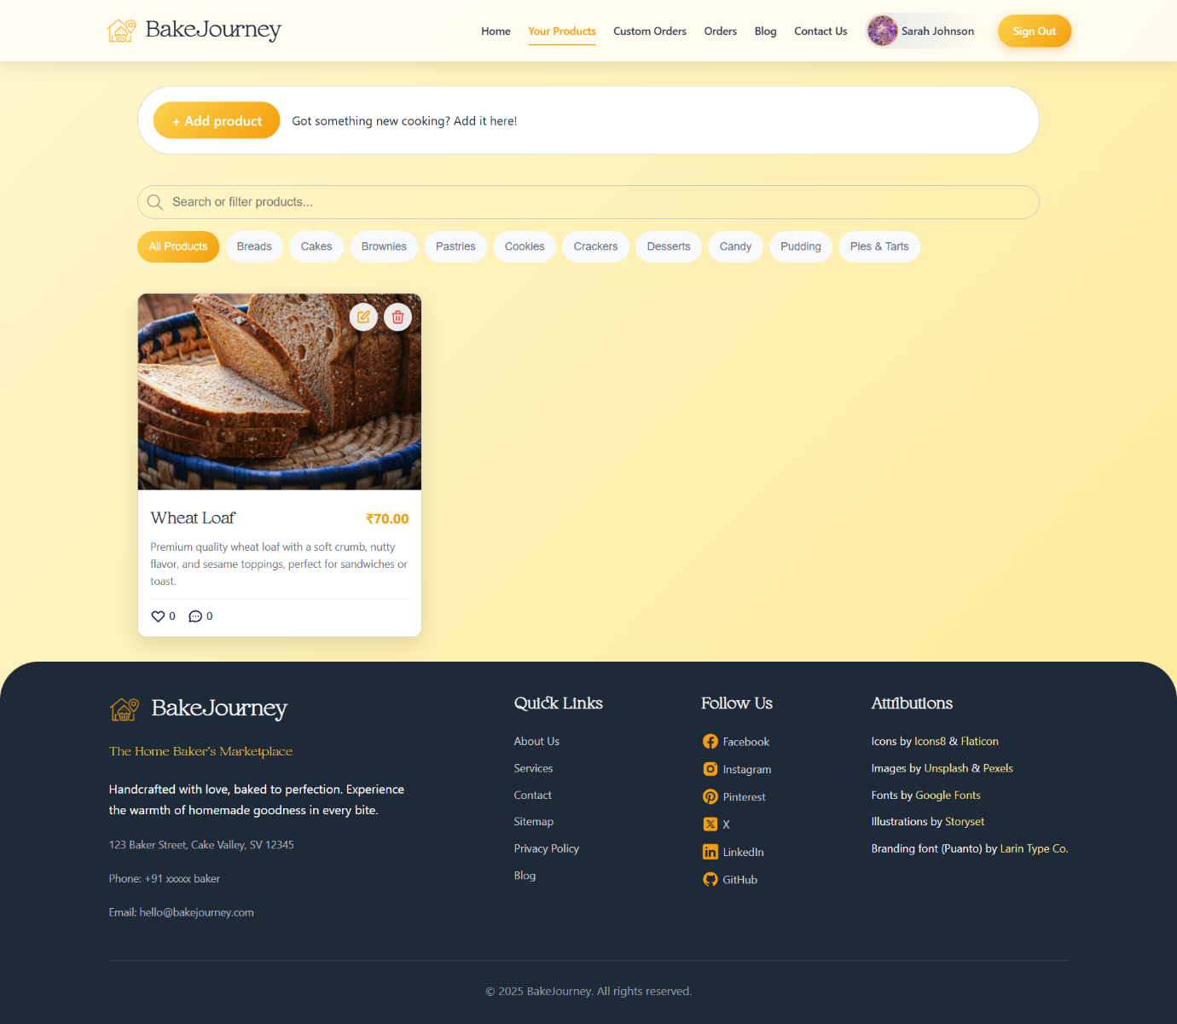

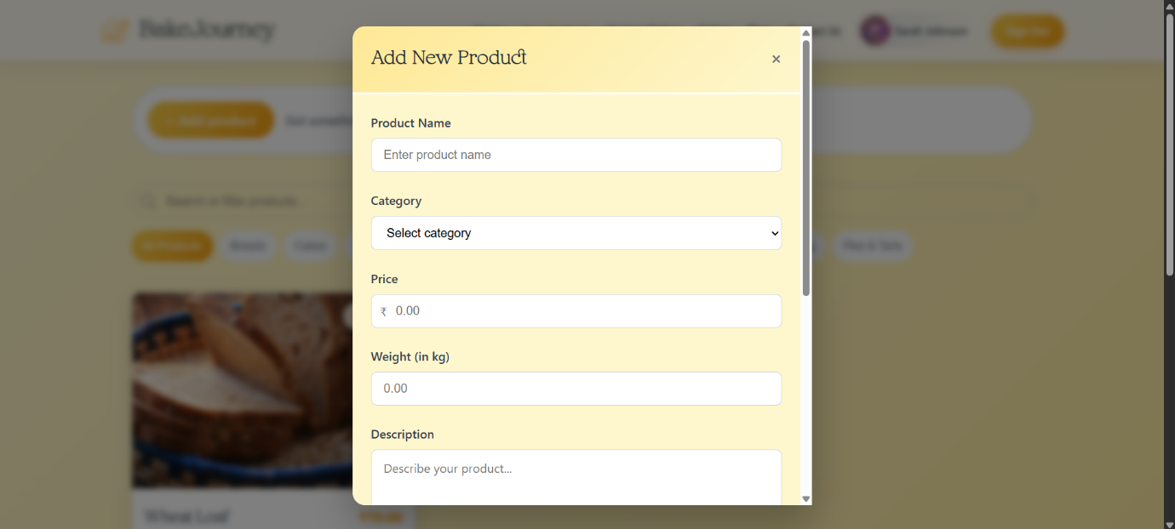

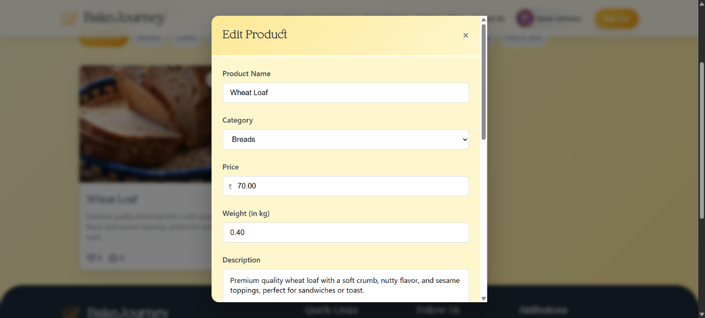

1. **CUSTOM ORDER MANAGEMENT PAGE**

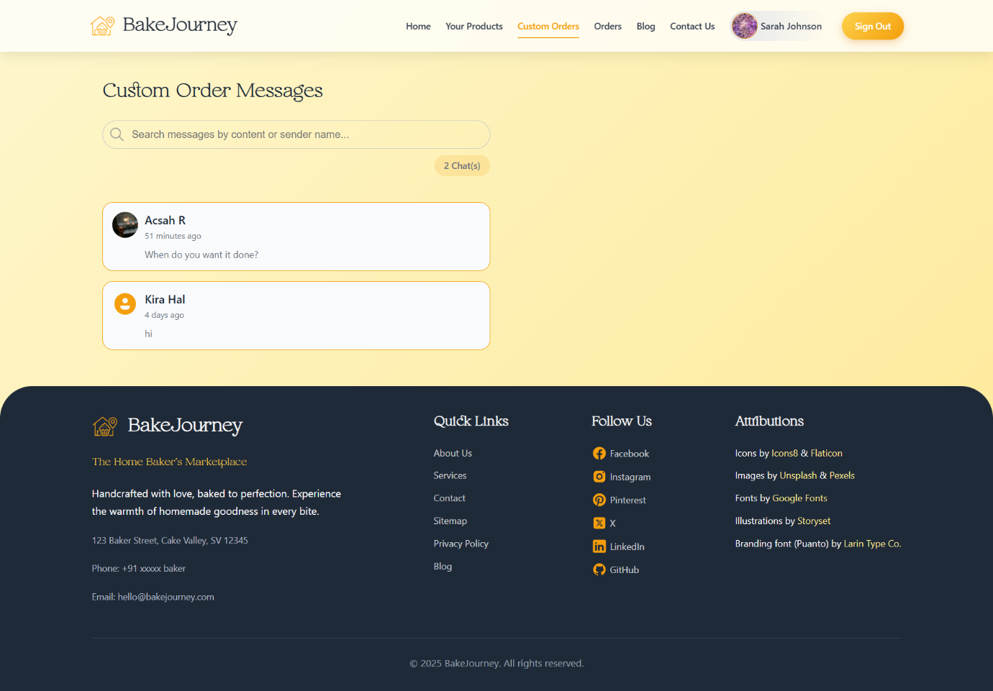

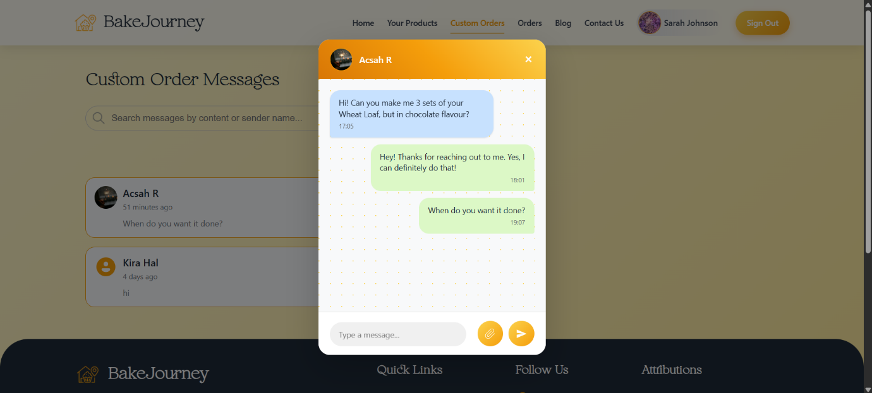

1. **ORDER MANAGEMENT PAGE**

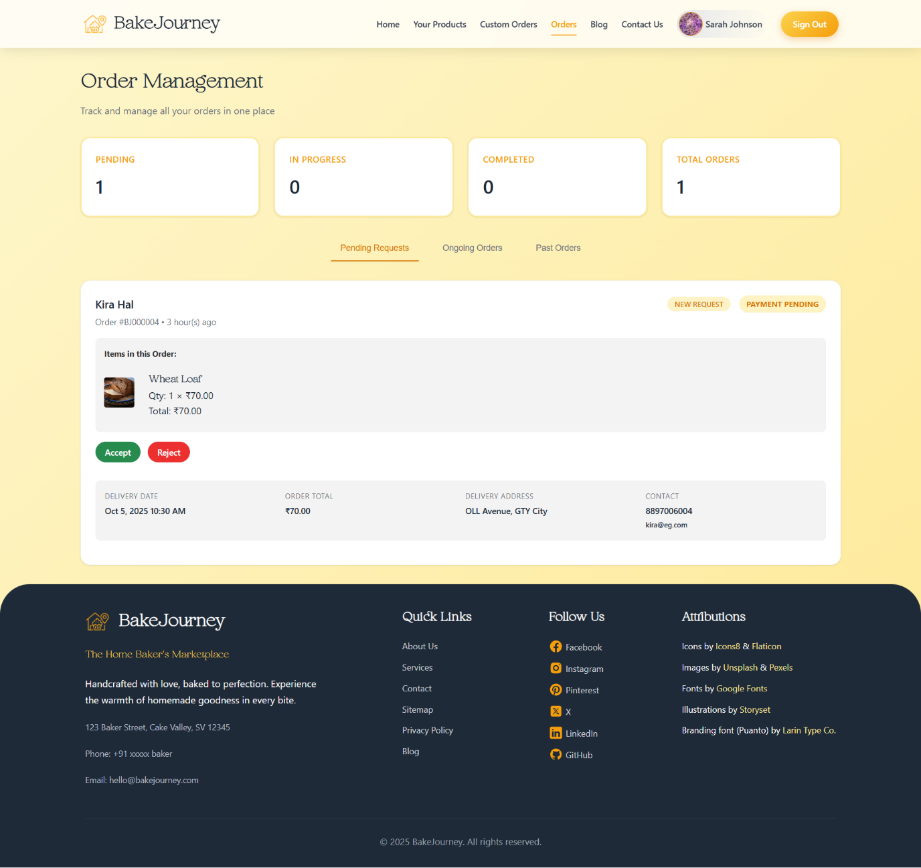

1. **BLOG MANAGEMENT PAGE**

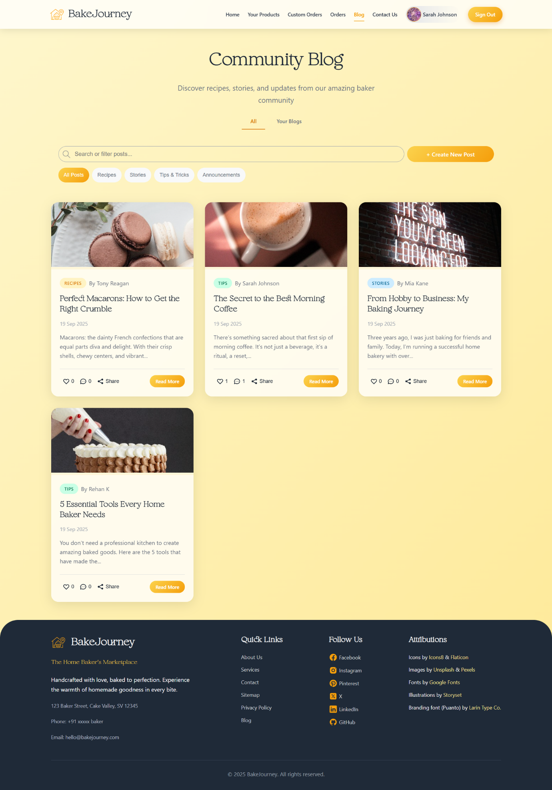

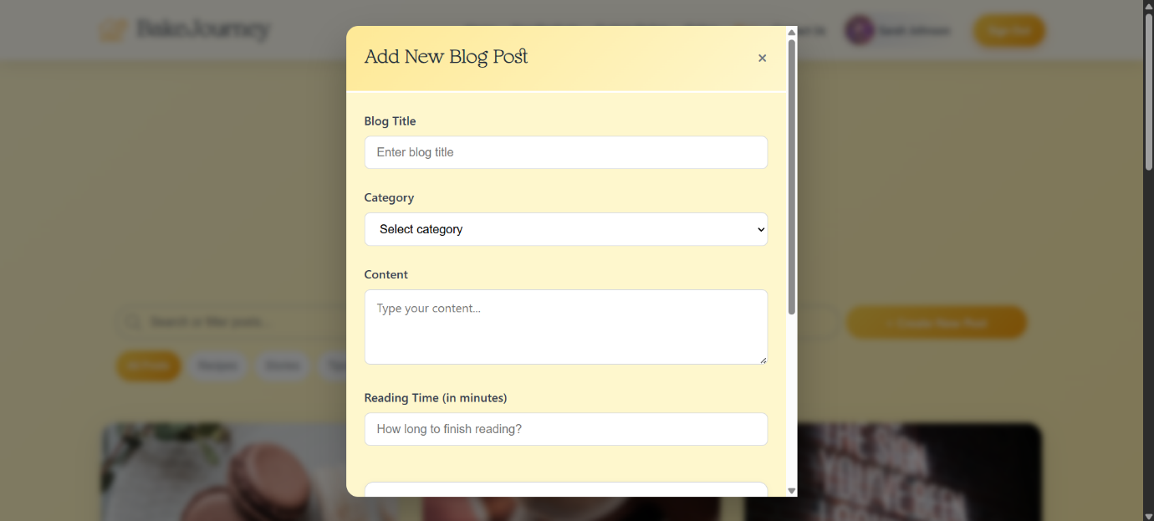

1. **BAKER PROFILE PAGE**

